[Summary]
For my final major project, I intend to produce a Virtual Reality Game. In the 8 weeks that I have I aim to make fully playable VR game that It is going to be a Horror game with the theme of shadow. This game idea was my best choice because it makes use of my skills in 3D modelling and environment building. I am going to use Unreal Engine to make my game, I will also model everything by myself in Blender.
Over the 8 weeks I will also do research on subjects that will help me in my game. Useful knowledge that could improve my work.
22nd April 2021
[Input Planning]
I have completed my Intended research and my project proposal, now that I have done this I can start work on the actual idea. Due to spending too long on my intended research I am behind on my schedule by four days. To catch up on my work I am going to shorten my planning down to one day and my blocking out to one day, this should bring me close to catching up and being on schedule.

I have started making some map designs. The designs have simple version of what I need, I have done two so far but may do more to give me more ideas of what looks better. With some spare time, I have also drawn a 3D sketch of what the cottage could look like on the inside.
On the map designs I want:
- House/cottage
- River
- Some sort of blocking mechanism
- Bridge
- Path
- Locations for trees

23rd April 2021
[Map Designs]
On my timetable I should be starting my Blocking out process today but in instead I am going to finish my map designs to get up to date. I have done a total of 6 map ideas that could all work.

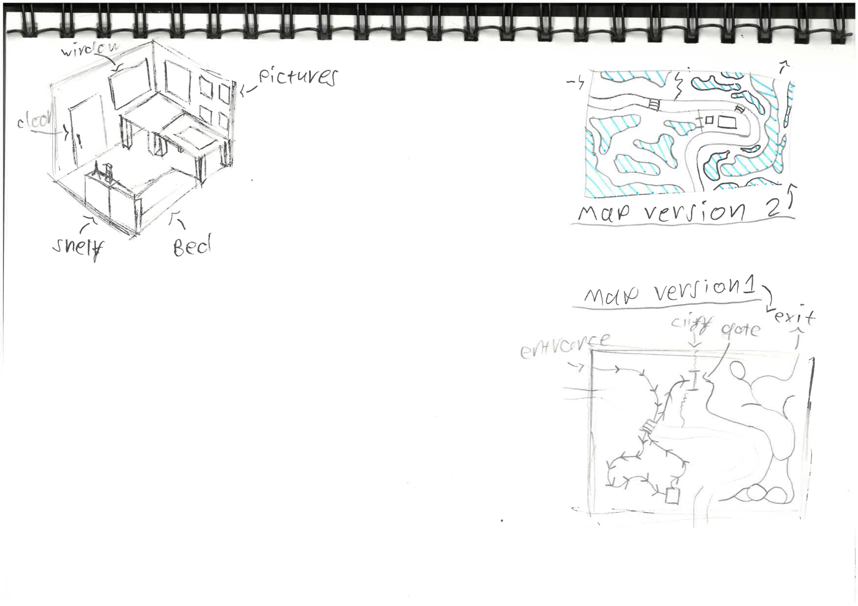
Map 1:
Simple environment with just 1 pathway through the first half of the map. There is a cliff with a gate in the middle to stop the player going to second part to early. You need to get a key from the cottage to open the gate. The second part has added pathways that lead to dead ends so the player will have to remember which direction they came from. This idea is too simple for what I am aiming for, so I do not think I am going to go with it.
A problem that this map will cause is that too much foliage will make the game lag and run slow which is bad for virtual reality games because it can cause motion sickness in some players.

Map 2:
For the second map I decided to go with a different style of map, by drawing where all the foliage will be with highlights blue lines. Everywhere else that is not marked is a path, except for the river that goes through it. I kept with this style for the rest of the maps. This map has two bridges. There is a gate that stops the player getting to the house to quick they will have to find a key in the forest where the enemy will first appear.
This is one of the better map designs and is in my top three to select from.
A problem this map could cause is that the player might not know how to open the gate, to help this I could leave a note or peace of paper that says there is a key in the forest that they must find. This could also make use to the fireflies which could lead the way to the key.
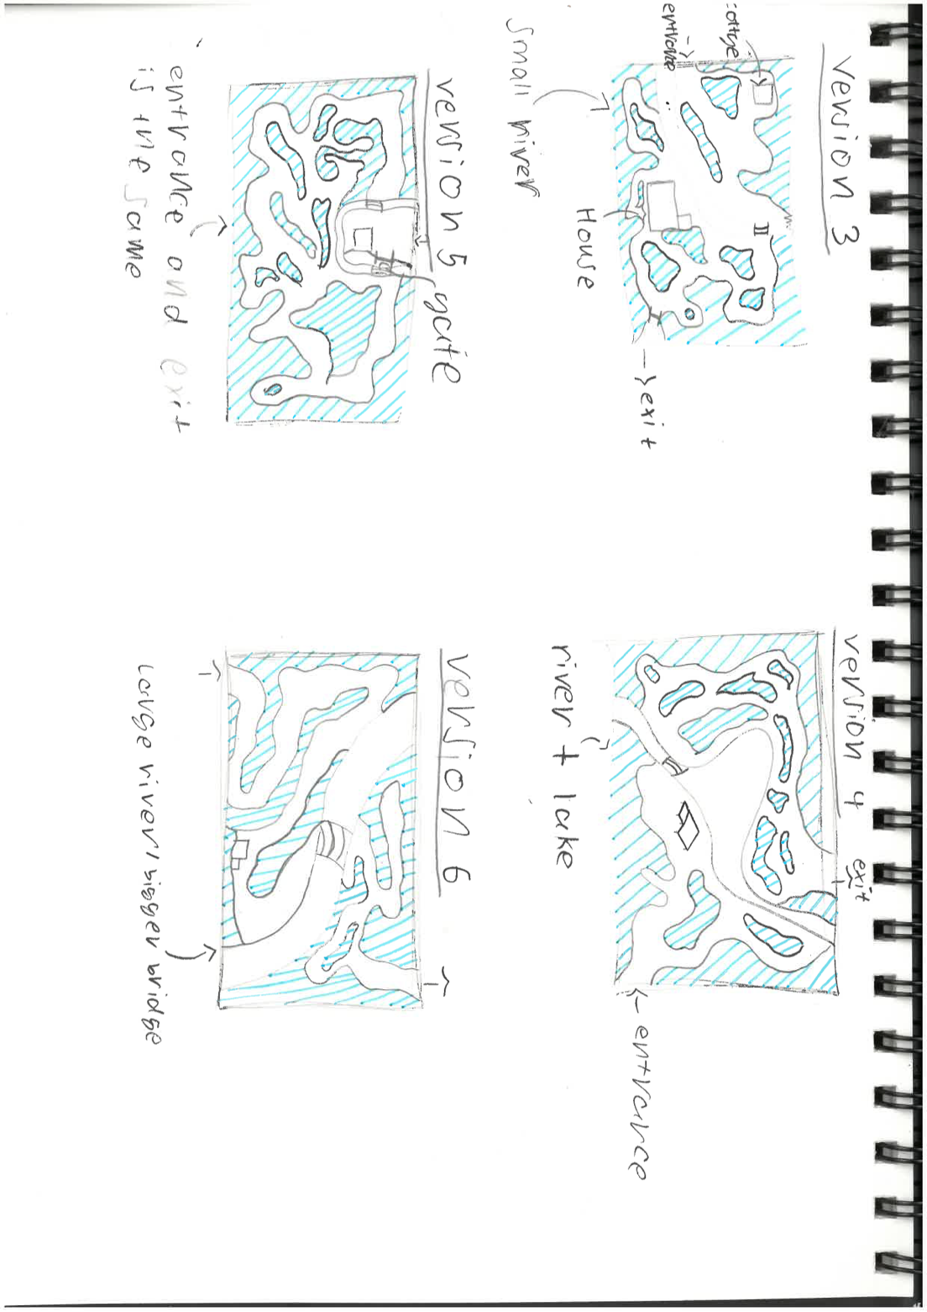
Map 3:
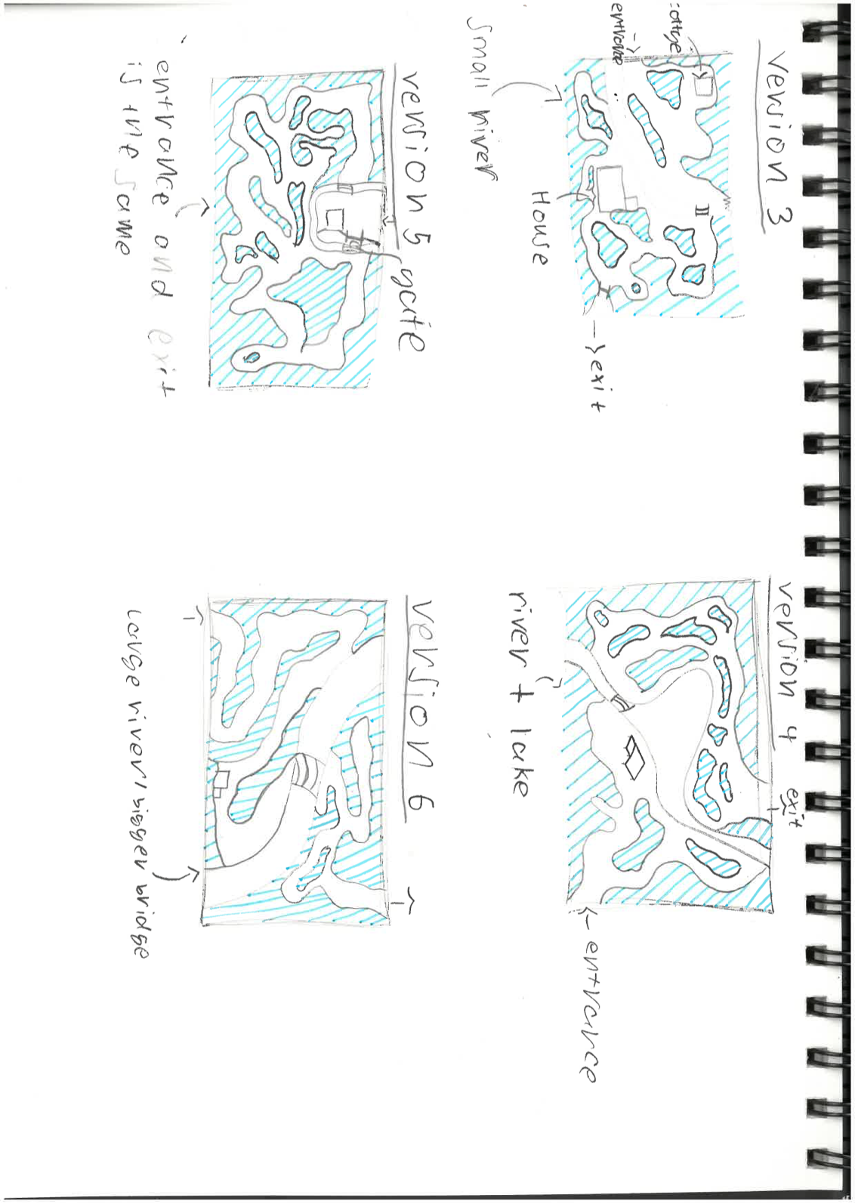
The third map is much simpler than the second one. It has a smaller river so much more land to explore. The difference with this map design is that there is both a cottage and a house. My plan is to make the cottage more of an introduction to tell the player what they must do. The house will be for the third scene where the player first sees the enemy face to face. After that they will have explore the forest more to find a key to the gate that blocks the exit. I like this design, but I feel like it will not take long for the player to finish the game because there not a lot of detours in the path.

Map 4:
The fourth map is my favourite because I made it have small river, but it has a giant lake in it. The map will still have lots of land, but instead will just be smaller pathways. There is no gate blocking the way, but I may add one in later if the game is too short. If I did this, then I could put the key either in the cottage or there is a pathway that is detoured from the normal path up the top right of the map. The second half of the map is filled with more detached patches of foliage that make it so you can multiple ways to the exit.
This map does not have any big problem except for having too much water particles might make the game lag.

Map 5:
For map five I went with a different approach to the environment, this time the entrance and the exit is the same. There is a small river that goes around the first part of the environment. The rest of the map is foliage and pathway.
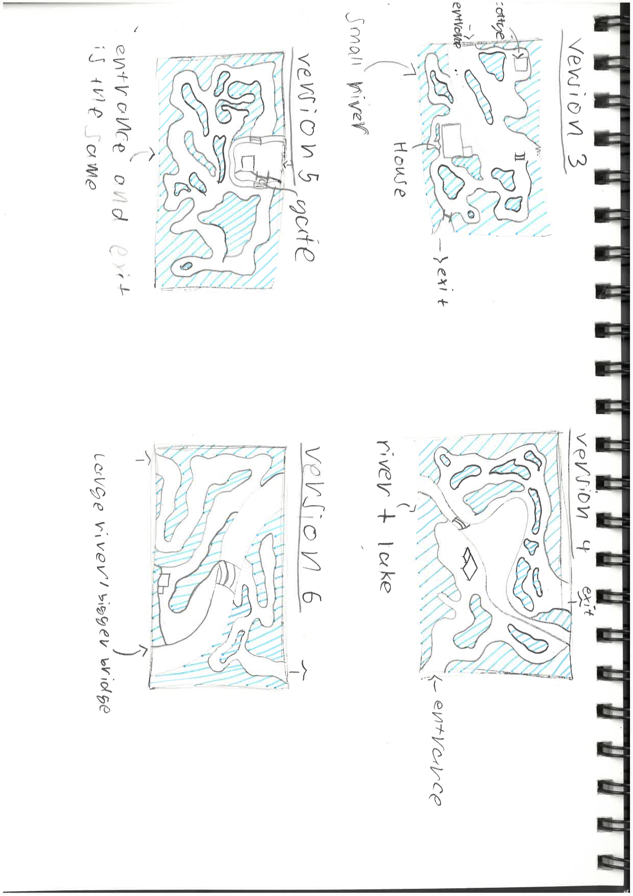
With the difference of the environment, I could do a different story line. The story could be that the player has to go find someone, they enter the house, and a note is left saying they went in the forest and they need help, when they cross the bridge, it collapses. They continue to search for the person and find that they are not alone. Around halfway through the forest they find the person but there dead, they have a note and key, the note says for the player to continue through the forest and find the other bridge and the gate to get back to the entrance.

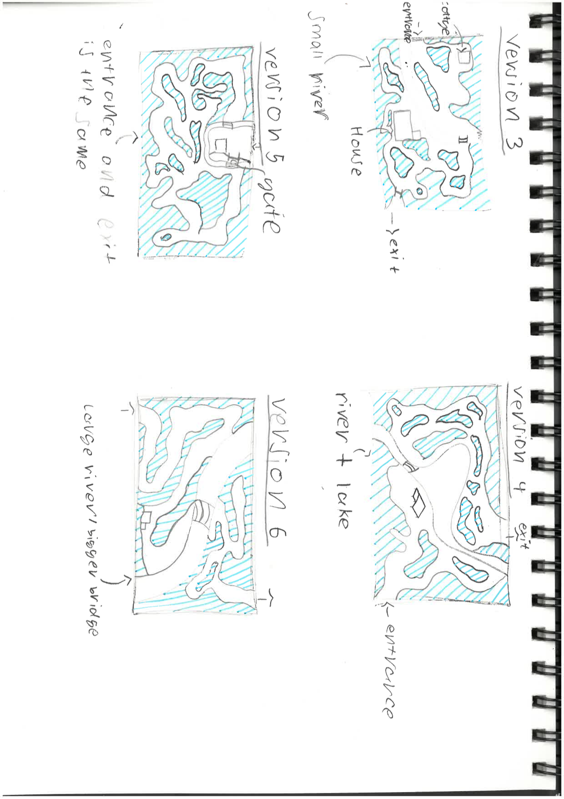
I like this story, but it is different to the one I am aiming to make. The player may also get lost in the forest bit because I added in a lot of detached parts to split the pathway.

Map 6:
For map six I tried going for a much easier map, with only one pathway the player will not get lost in circles. I made it simpler because from experience I know that in Virtual Reality you can lose you direction very easily, so to solve this future problem I made a single path. This map also has a larger river than the others.

My intended 3 scenes were:
- Entrance Scene
- Introducing enemy
- Escape
With the second half of the environment, I think I will add in a fourth scene as an escape scene, so you are trying to escape from the enemy.

From looking at all my map designs I feel like the top three that are best is 2,3 and 4.

2 is good because it’s a mix of simple pathing and complex pathing for the second half. The player should be able to tell which way they need to go to get the exit.

3 is good because it adds in a lot more story that can make the game last longer, even though the story for 5 is longer it does not fit with what a envision the game to be.

4 is my favourite design and it has enough for the scenes that I want. Straight from the entrance you can see that there is a building. From there I could make it, so the player must go find an item or go straight through to the rest of the forest and escape from the enemy. I think this design is my best choice because it gives me enough and if I need to add more on the map later there is enough room to add in extra objects.

Now that I have chosen the design I am going to stick with, I can start on the story details and blocking out the world.

27th April 2021
[Experimenting]
Right now, I should be doing my world layout but currently I am at my blocking out stage. This makes me 7 days behind my schedule to get the game finished on time. To fix this I am going to spend only a day on my blocking out, create the testing world the same time I make my actual world. I will spend a day on planning out the story. By changing these timings, it should bring me back on time to get the game finished by the end of May and to give me enough time to fix anything if needed.
For my blocking out I am going to use Blender to see what it looks like first then if I need to make any changes than I can do. This will save me more time than if I did in Unreal because then I would have to create three Unreal Instances when copying the map over. I would also rather save the Test world for more material testing and model checking.

I started to do research into subjects that could help me with my project. I had a Word document ready a couple days ago to start on it but I feel it will better if I did it in Powerpoint because it will look nicer and will be easier for images.

I did some testing of what I would want the grass foliage to look like. And this is how it came out looking. I did this in in Blender because I know the software well enough to be able to make stuff I want. 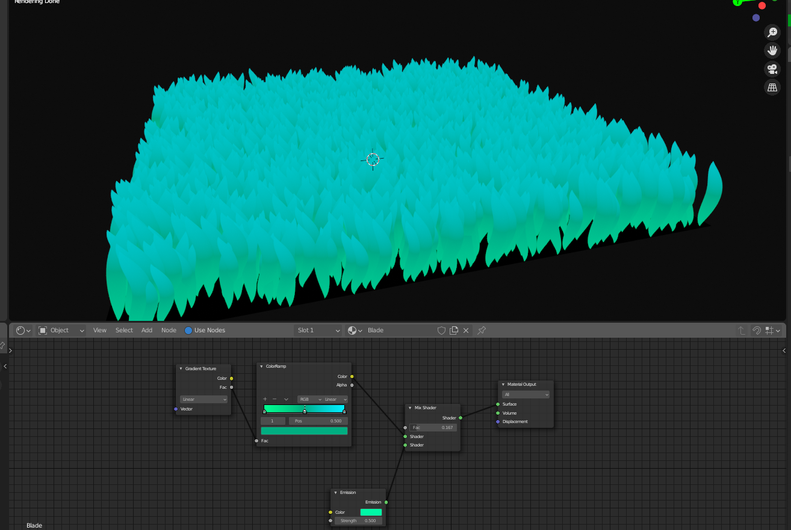
I made the material by having a gradient node connected to a colour ramp that had vibrant blue and green, that connects to a mix shader that also has emission going to it then you just connect to the material output.
This is what it looks like using Cycles rendering with very high contrast.
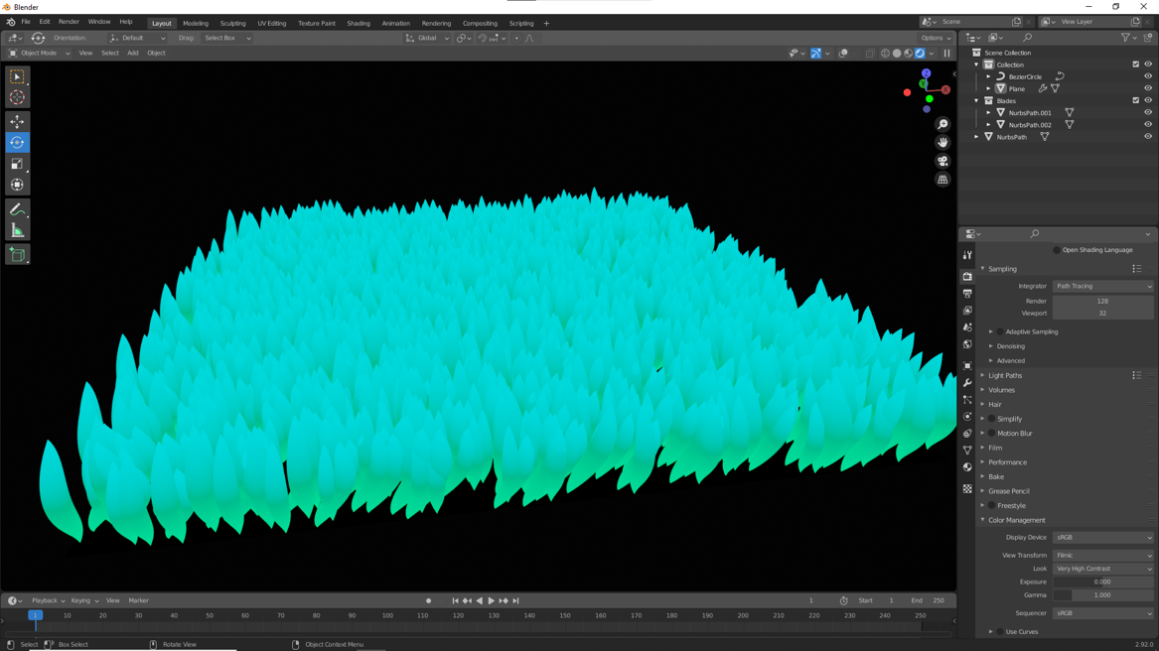

30th April 2021
I decided to do some more testing so made a tree in Blender using a add on, the only problem with the plugin is that you can’t edit the tree anymore after closing the editor which means I have to create multiple trees to keep on editing them. This tree is very similar to what I want but is not the final tree that I am going to use. For future ones I would more leaves to be able to cover up more vision, I may also make some trees with a wider trunk to make it so the player can’t get through the trees easily.
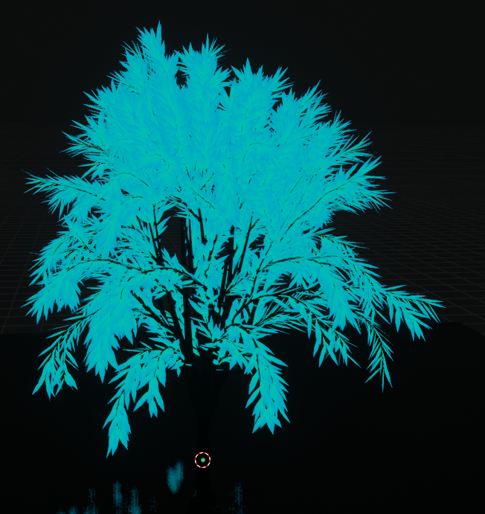
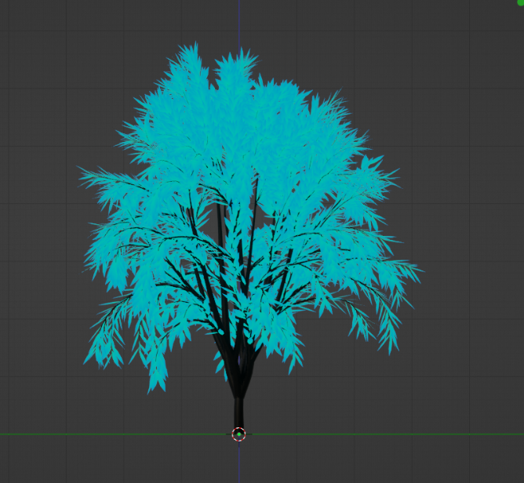

I decided to make the tree woods material black because that is how I see it being in the game. The only plant life I want illuminated is the tree leaves, mushrooms, and flowers. This is to make it so not everything is glowing. I want the tree leaves to be bluer and the grass to be greener, this is because I want contrast in whether the player is looking up or down in the world.

I have noticed that I have not been doing my work consistently, so I am going to try harder to get stuff done daily and written in my Production journal. I am going to try get all my planning work done with in the nest three days so then I can do all the practical work throughout May.

[Full Story]
Finishing writing the full game story and added in some details to the map. [File: FMP Story]
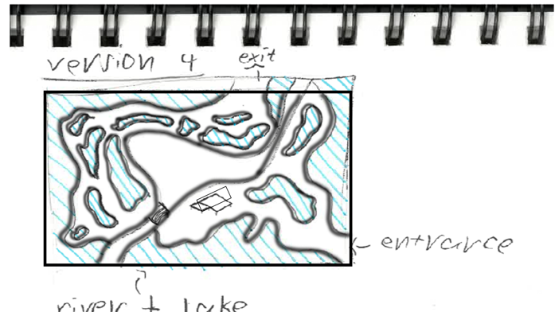
[Map Rework]
Once I had written my story, I did a rework of my map design to make it look better and so I did not have to just go of my sketch.

First, I put my sketch into Photoshop and drew over it with shapes and the brush tool.

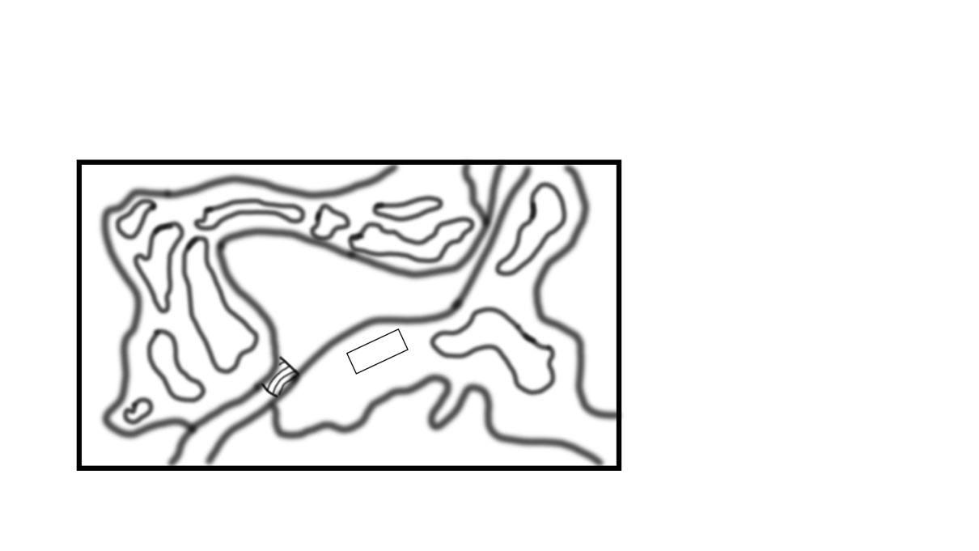

This is what it looks like with just the lines done with the brush tool. I did not like how bad the drawn lines looked so I decided to do it again but using the pen tool because I want more of a solid look to the lines.

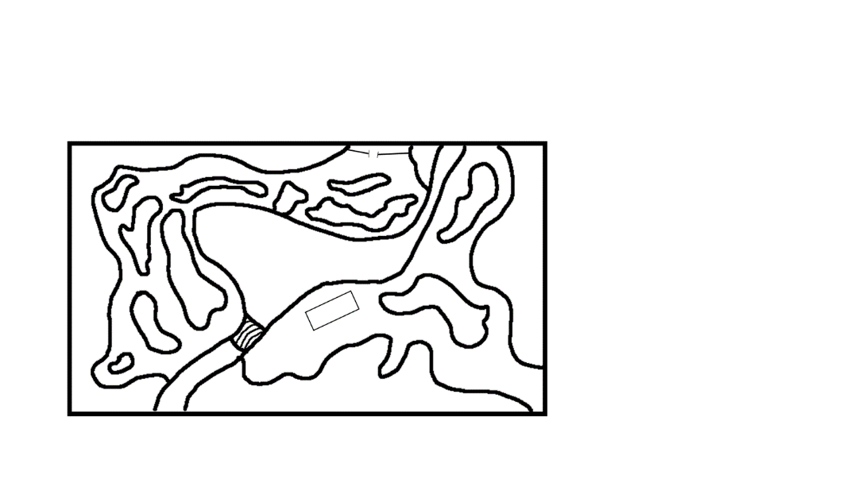
This is what the map looks like with the lines with the pen, and I do think it looks better than it did before.

This map will be better to go of when I do my blocking out because I can see the lines much better, and I can just match up the lines with the shapes in the preview.

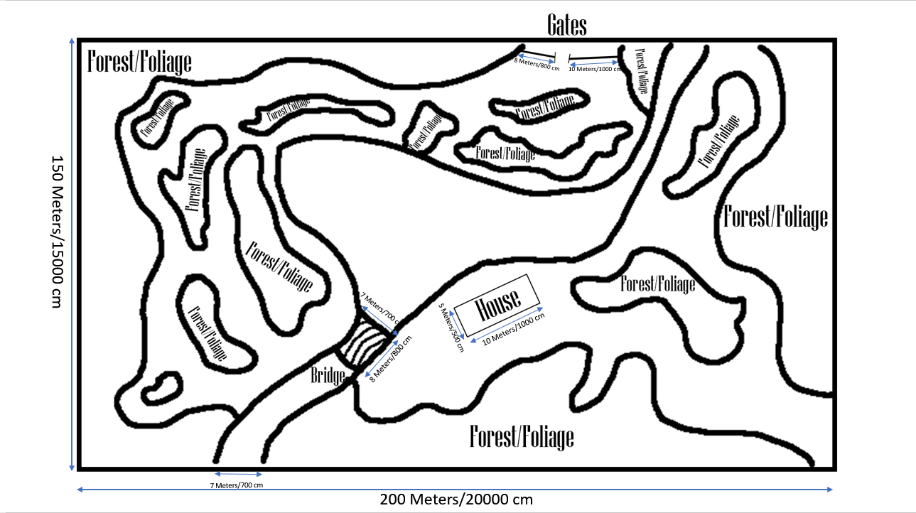

Here is the map with rough measurements of the world and some of the main parts of the map. This is rough because Unreal engine Measurements are different to other game making platforms. This will mean it may not transition well.

With all the changes to my Gant chart I decided to make a new one that is more up to date
with my timings.
[New Gant Chart]
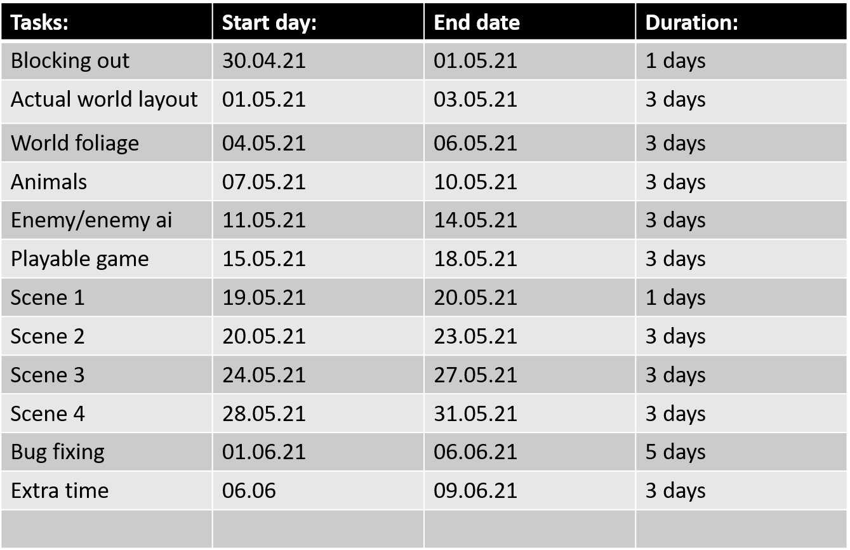
With all the timing changes this should give me enough time to make the game and finish like I want it. Learning from how I got so behind on my work from the last chart I think I can stay on track with this one. I may get behind on some of the tasks, but I still have 3 days extra to use up still if needed. I could also finish 2 tasks in the time of one and be ahead of my schedule.

3rd May 2021
Thinking more about of how scene 3 will work I feel like it will take to long to make it so the shadow follows the player. To make it easier on myself I’m just going to add some scary scenes instead for example the shadow flies in front of the player through the trees.
[Blocking Out]
Doing my blocking out I used Blender, first I created an empty scene and added my detailed map design as a reference picture. This was to make It easier for me to place blocks exact to the map.
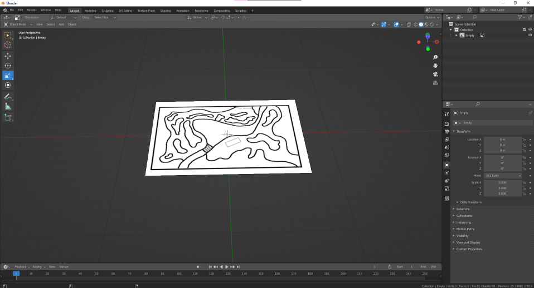

Then I add the base cube for the ground and match it up with outline of the map.
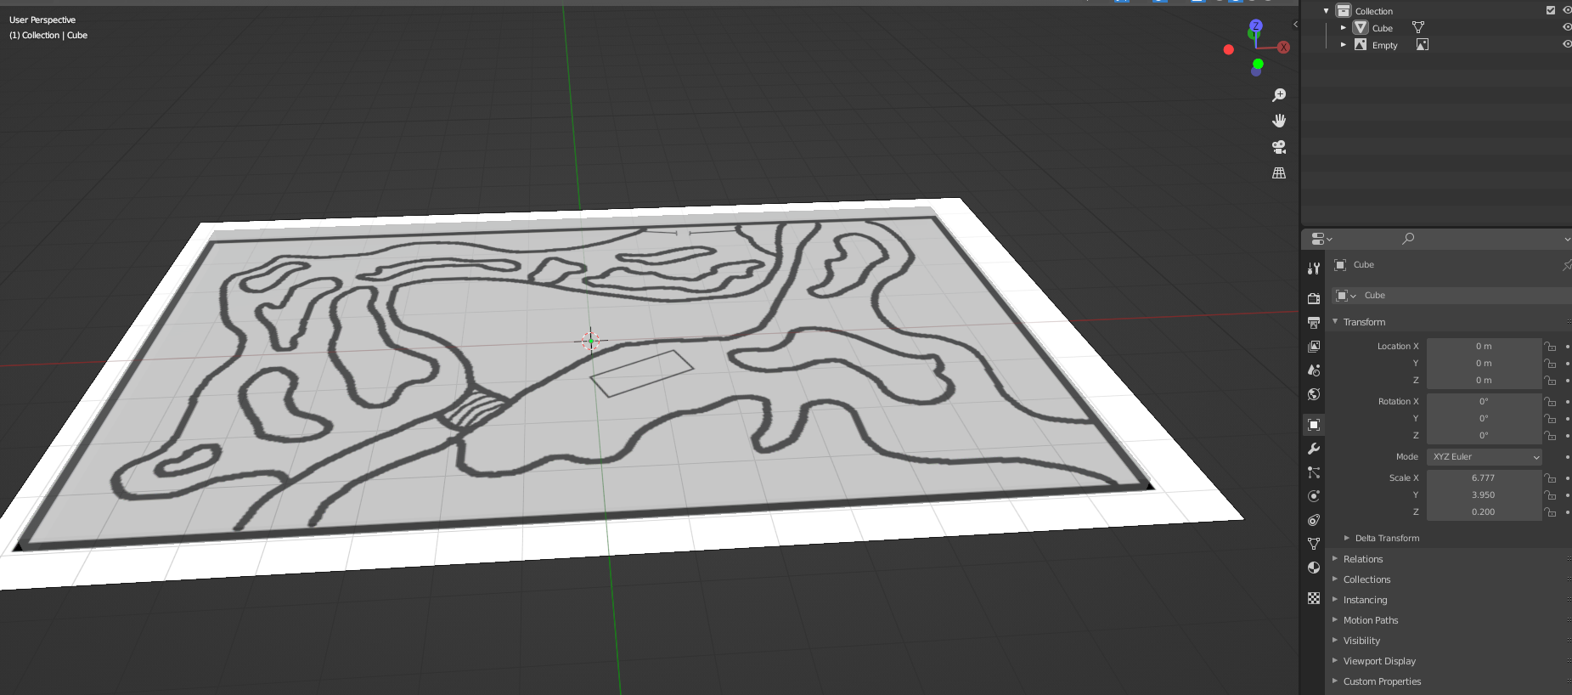

Next I added in a cube to do the river, I made it small and kept on extruding one of the faces over and over again to fit as much as I could do it. When I do the river in Unreal Engine I will use a sculpt tool or I will just select around the outline and bring everything else up.
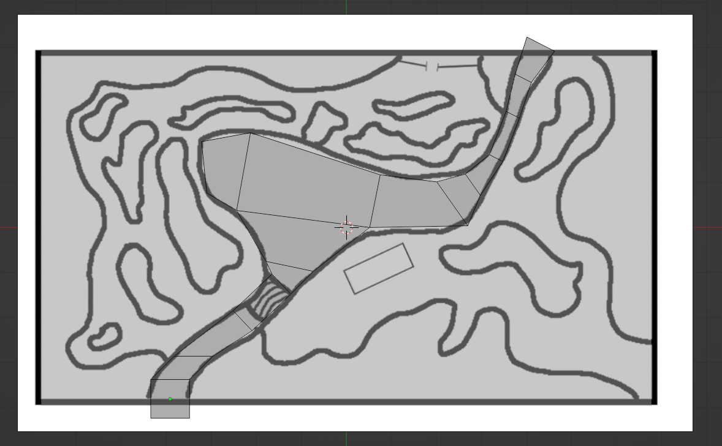
To make it a cut out in in the base cube, I added a Boolean to the base case and told it to keep the difference between them. Since this is just blocking out, I’m not going to focus much on getting the lines perfect but in Unreal they will be a lot smoother rather than just lines.
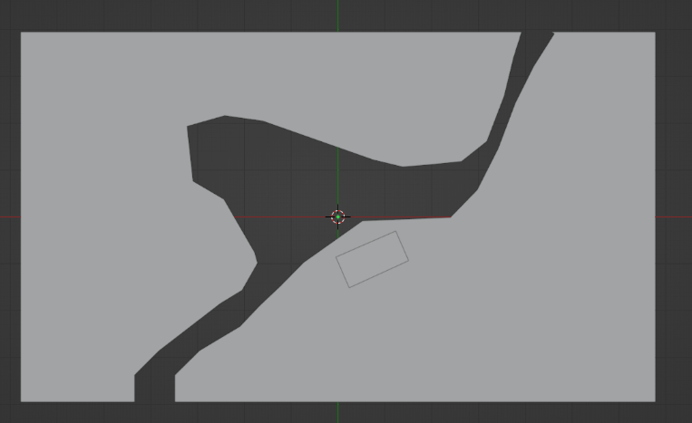
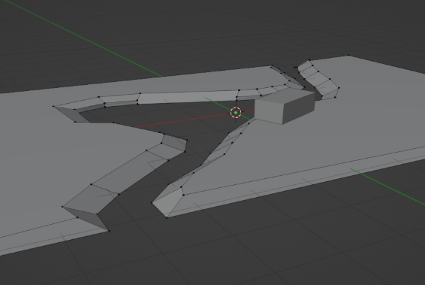
Now to make the edge more like a lake side I scales up the top edge to make it look like this.

From this I realised how big I had accidently made the cottage, so I have had to downscale it a lot. To create the water I added a plane, scaled it to the right size and gave it a blueish material. I did this by connecting a noise node to a colour ramp and then connected that the to output.
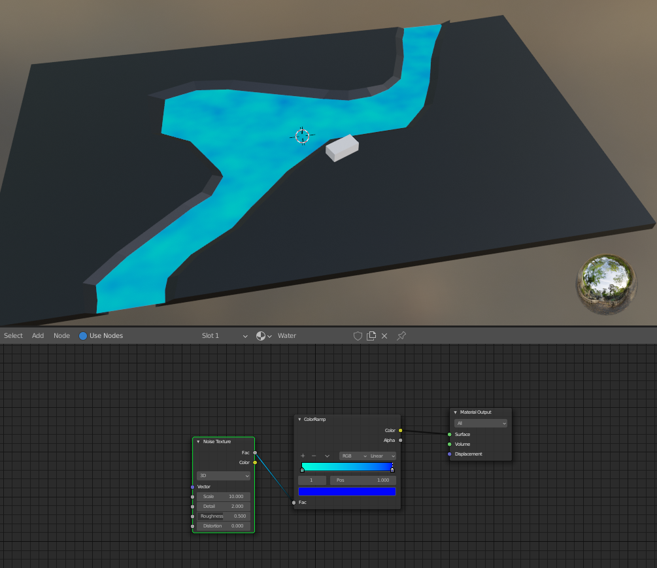

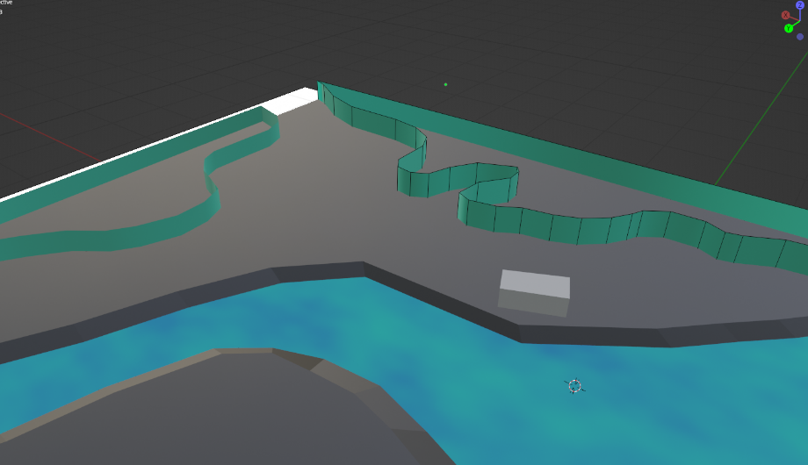
Now with the water done I am going to outline the foliage areas. In the Unreal version I will just add the plants and trees straight away but because I cannot do that easily in Blender so I will just outline it. This is to make sure that I have enough space for the player to walk on the pathways. I did this by having one line and keep extruding it around the outline I want.
This is what it looks like with all of them done. I also added a emission node to the material.

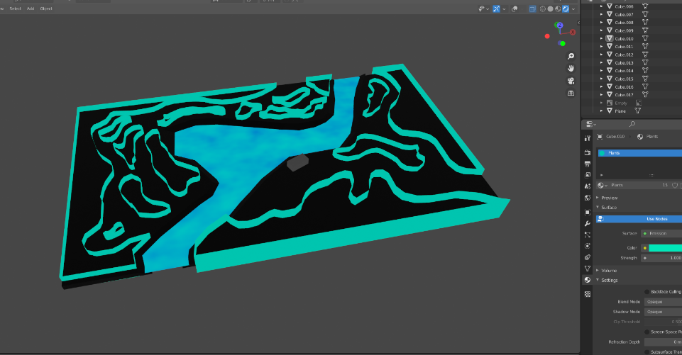
With me just using lines, when I was in top down view I wasn’t able to see any of them so I have added a face on the top so that I can see them now. I also changed some of the sizings of the foliage because they went over the river because I used the map design to create them.
(Overview of the map)
This is what the map looks like from a top-down view.

Now I just need to create the bridge across the river and the gates. This will be easy to do because I just need to scale up a cube to make a wall which is easy.

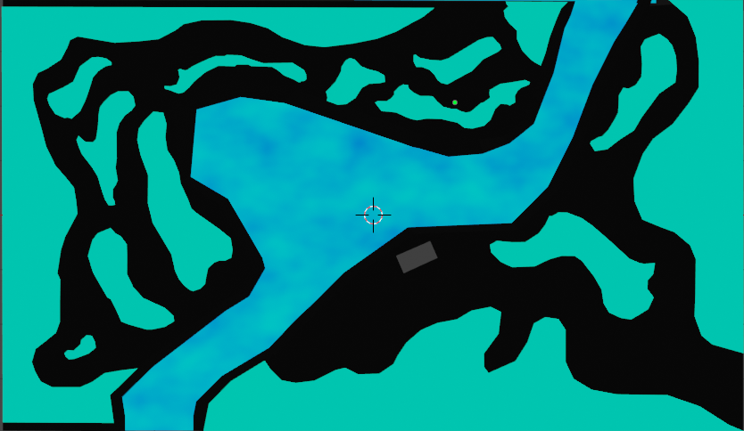

With all that done this is what the final bit looks like. From now on I will use this as my map design to go off. This will make it much easier for me to make it unreal.
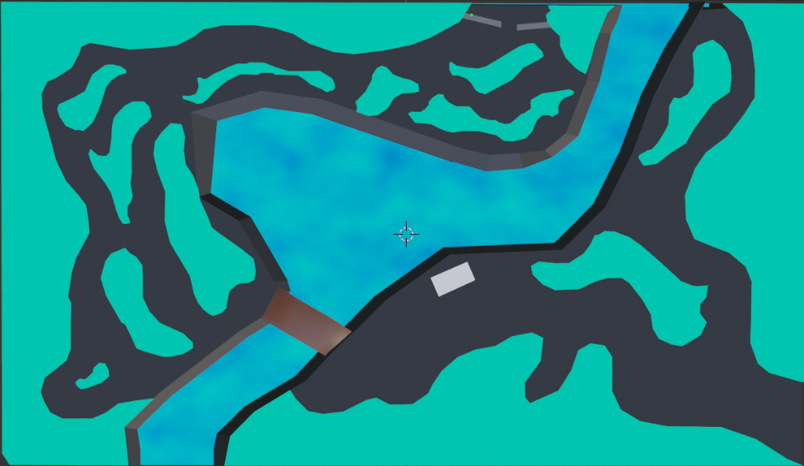

Now with my Blender blocking out done I will transition it over to Unreal Engine as best as I can.

5th May 2021

Before I started doing more practical work, I wanted to do more research into subjects that could help. I looked at already released popular VR horror games and found three that could be useful to me.
I also looked at what makes people so scared of the dark and shadows. This can help me so much in my game because I want to make the player feel like they should fear being in the dark. My goal is to start this at scene two and then enhance on it in scene three.

6th May 2021

I started testing of how to make my grass in Unreal engine and by this I found that when I imported my grass blades models they were too big but I could change them by editing the scale. Since because I know that the average height for a character in Unreal is 0.88 metres which is 1.88 metres in real world measurements. I had to measure what the size would be if I wanted the grass to reach the players knees. Using a ruler and measuring from the floor to my knee is around 60cm. this is perfect height that I want the grass. Here is a diagram that I drew to represent this finding.
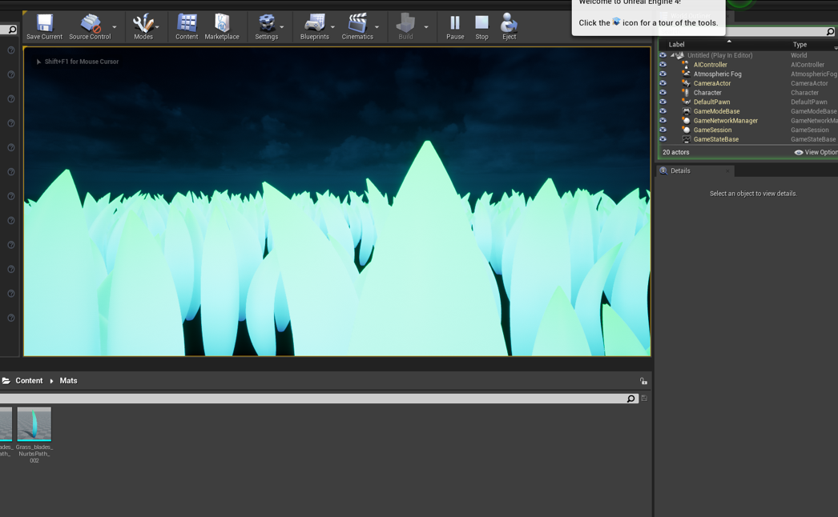
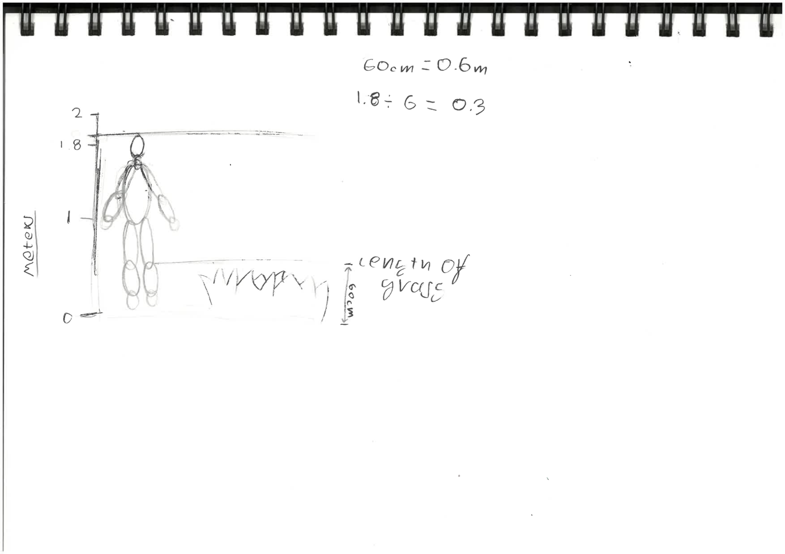
Even After doing them calculations, I was still wrong, but I found out my problem was that the grass models height is 2 metres, not 1 metre. This means I must divide my number again by 2. This will will that the height of the grass is 0.15 and not 0.3.
After doing this it looked like they were to spread out, so I increased the density from 200 to 300. The problem this causes is to many instances which will cause lag and slow rendering.
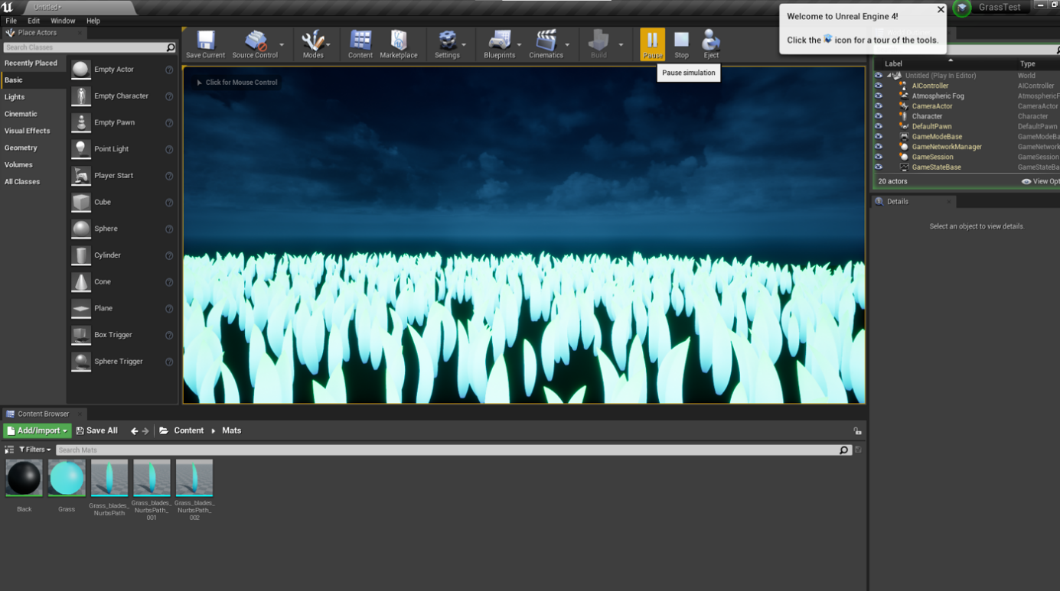
This looks much more accurate to what I want than before. I think to solve this problem quicker later on I will just make the grass models smaller.

7th May 2021

From some feedback I have gotten I have realised….

8th May 2021
[Big Problem]
Trying to create my Unreal Project and a Big Problem has occurred. When I try load the project it gets stuck at 39% or 45%. Looking at my pc task manager the CPU usage is at 100% and this may be the cause. After 2 computer crashes and trying to open it again, I have decided to go online to check if there is a way to resolve this. I came across a Unreal Forum were people were having the same problem. Looking at some of the comments there was one that stuck out because it was my exact problem.
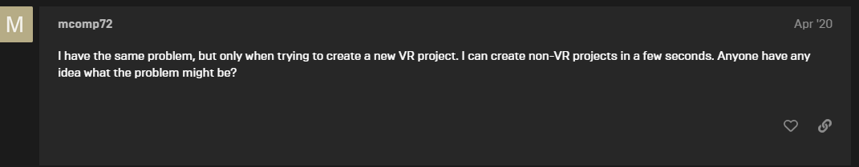
This was the exact same problem I was having because I was trying to open a VR Unreal Project. Looking at more comments one person and said they have found a way to resolve it with a link to a YouTube video.

Following along what the video says and it worked. My issue is now resolved and can open my Unreal project. [Video: https://www.youtube.com/watch?v=xy-_j0-WKNY ]

Even with the problem solved, my computer might not be able to handle having a VR project open. Due to more problems occurring by using Unreal Engine, because I want to stick with making a VR game, I am going to switch to using Unity Engine, I already have some experience in Unity but will still have to watch Tutorial videos.

I know that this is going to be a huge difference to how my game will end up looking like and playing like. Researching into Unity VR games and it appears that it is much easier to make a game for VR in Unity rather than Unreal. Another good reason to use Unity is that it does not crash as much as Unreal does.

My plan will be to make the environment like I want it in Unreal but when I am done, to transfer everything to Unity and make the game part there.

There is a lot more documentation on making VR games in Unity.

12th May 2021

Due to motivation issues, I still have not started making my game. This has caused to get behind in my work and my schedule. Right now, I should be done with the environment and starting make the enemy AI. To help catch up I may have to decrease the size of the world and making the scenes smaller. Realising how hard it is to make a VR just by myself I set to make work for myself.

Try to motivate myself to make my environment I went out and took some picture in woods nearby, there is also a river right next to it.

14th May 2021
[Where my Project will go]

Thinking about what I am going to do with my game when I am done. If I do end up finishing the full game, I hope to package it up and put it in itch.io so anyone can download it and play it. Alternatively, if this does not happen then it will still be good to put on my portfolio to show that I can make a game myself. I would want future business options to look at the game.

16th May 2021
[Starting Environment]

Just getting started with making my world. To set up the world for VR use all I add to do was enable the OpenXR plugin in the Unity settings. Choose which headsets I wanted my game to work on. After that I had to add the XR rig to the World, this is what enables the use of VR.
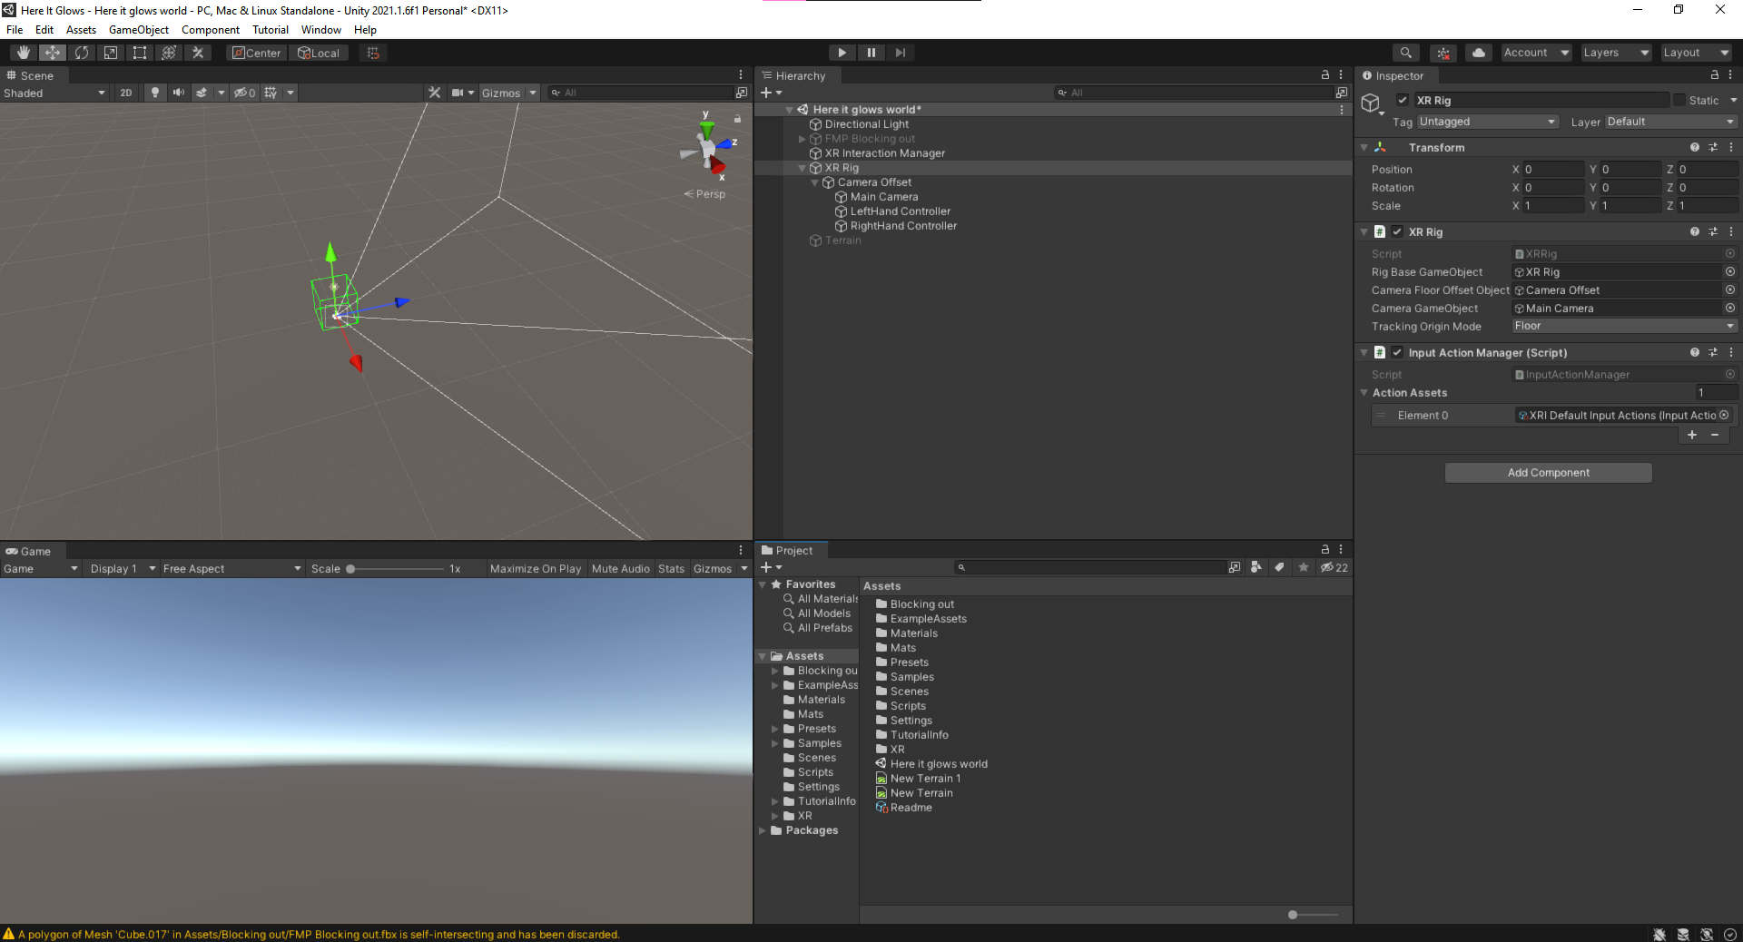

Once that was all setup a added my terrain because this is how I am going to make my ground and mountain barrier for my world.
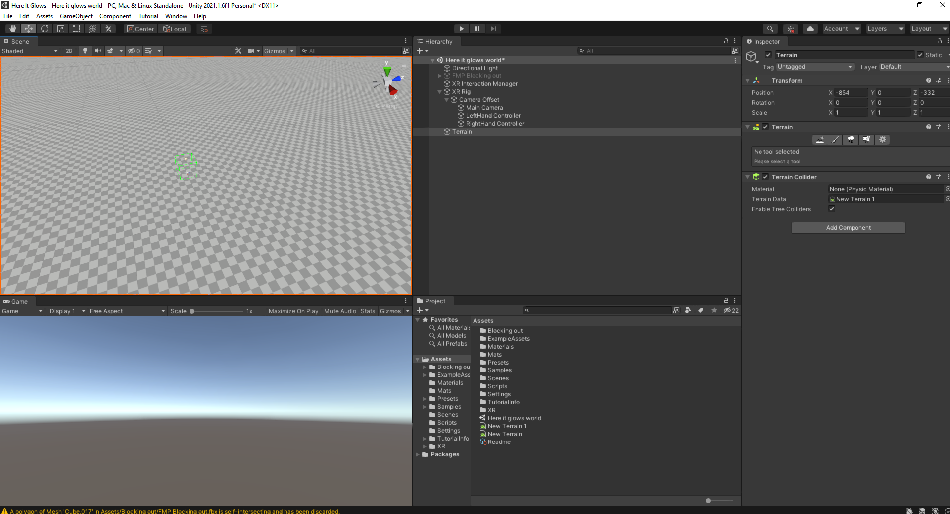

I knew that it would be hard knowing where the start with just the blank terrain so I decided to import my blocking out model from Blender to Unity. This is just to help me know where to start in editing the terrain.
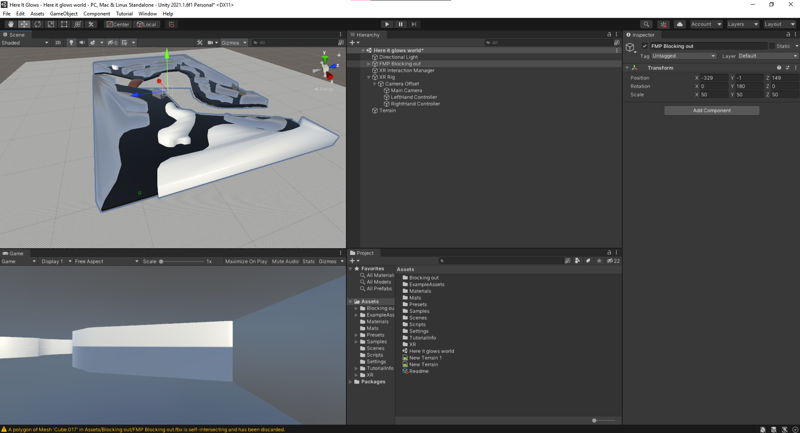

I built the all the hills that would surround the map. I did this simply by raise the terrain around the map.
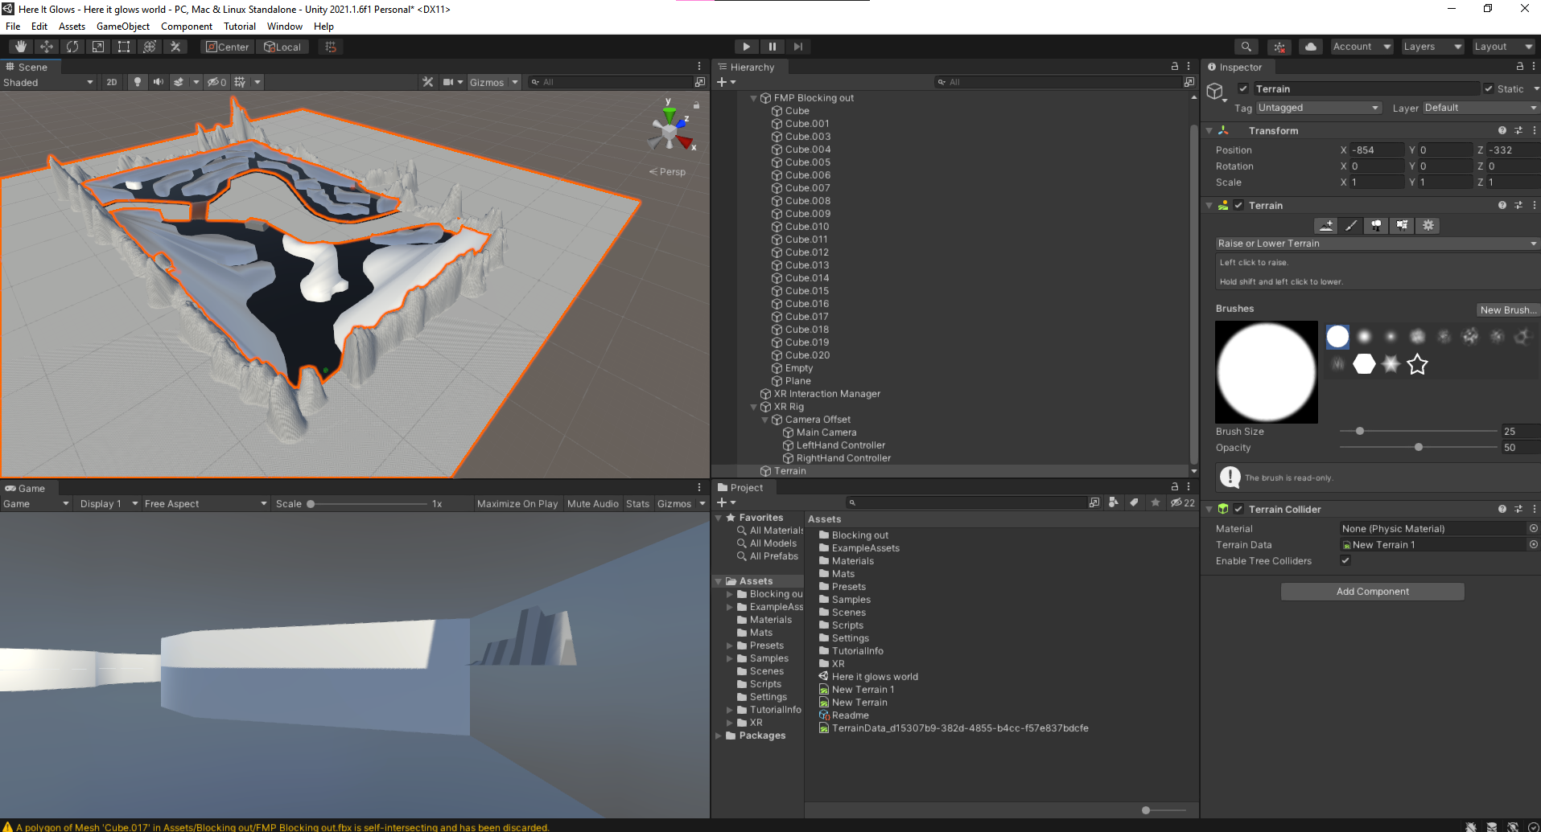

[Problem]

Comparing the world to the XR rig I realised that the world was way to big for what it should be. To solve this, I scaled down the terrain and blocking out objects from 100 to 20, this looked about right. To make sure I had it right this time I placed a 2m tall block next to the rig because that is the height that I was when I tested the world in my VR headset.
This also meant I had to redo the surrounding barrier around the map.
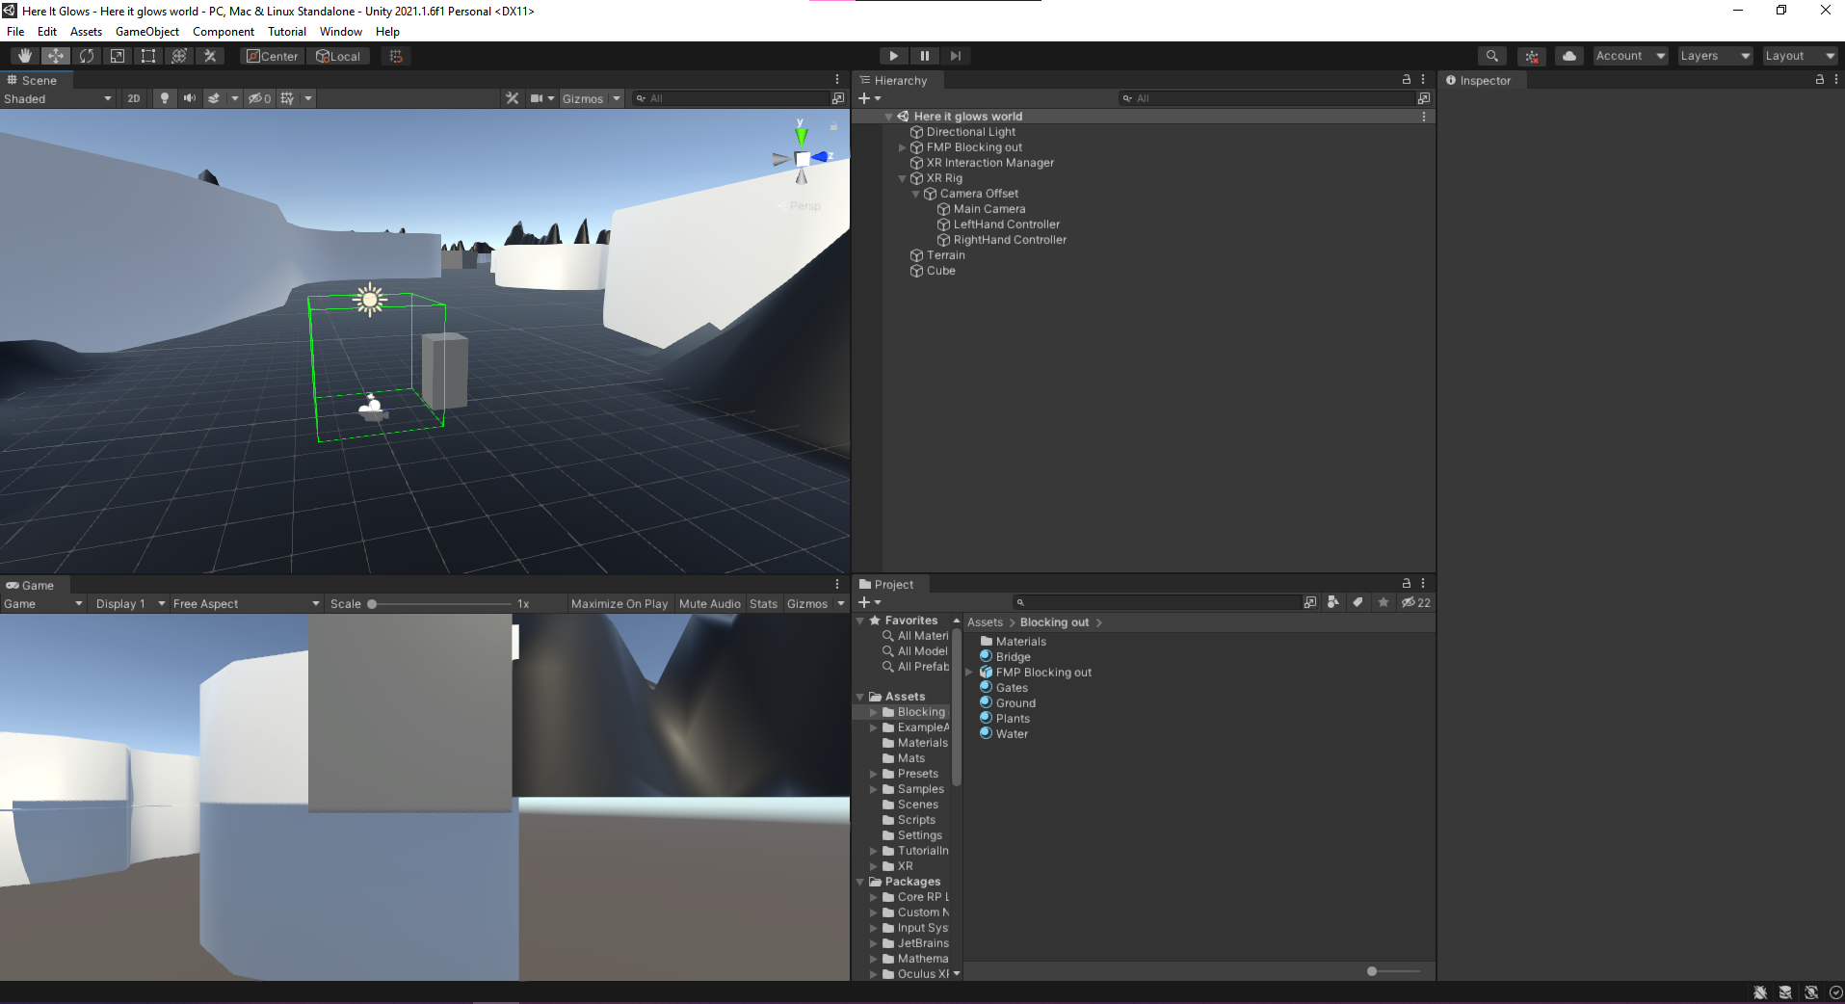

[Problem]
With this problem solved, I found another problem. Because the terrain is flat it means that I can’t lower the terrain any more than it is, which is of how I was going to do to make my lake. To fix this I raised all the land by two and then lower the parts where the lake would be. This also gave my ground some level instead of just flat land.
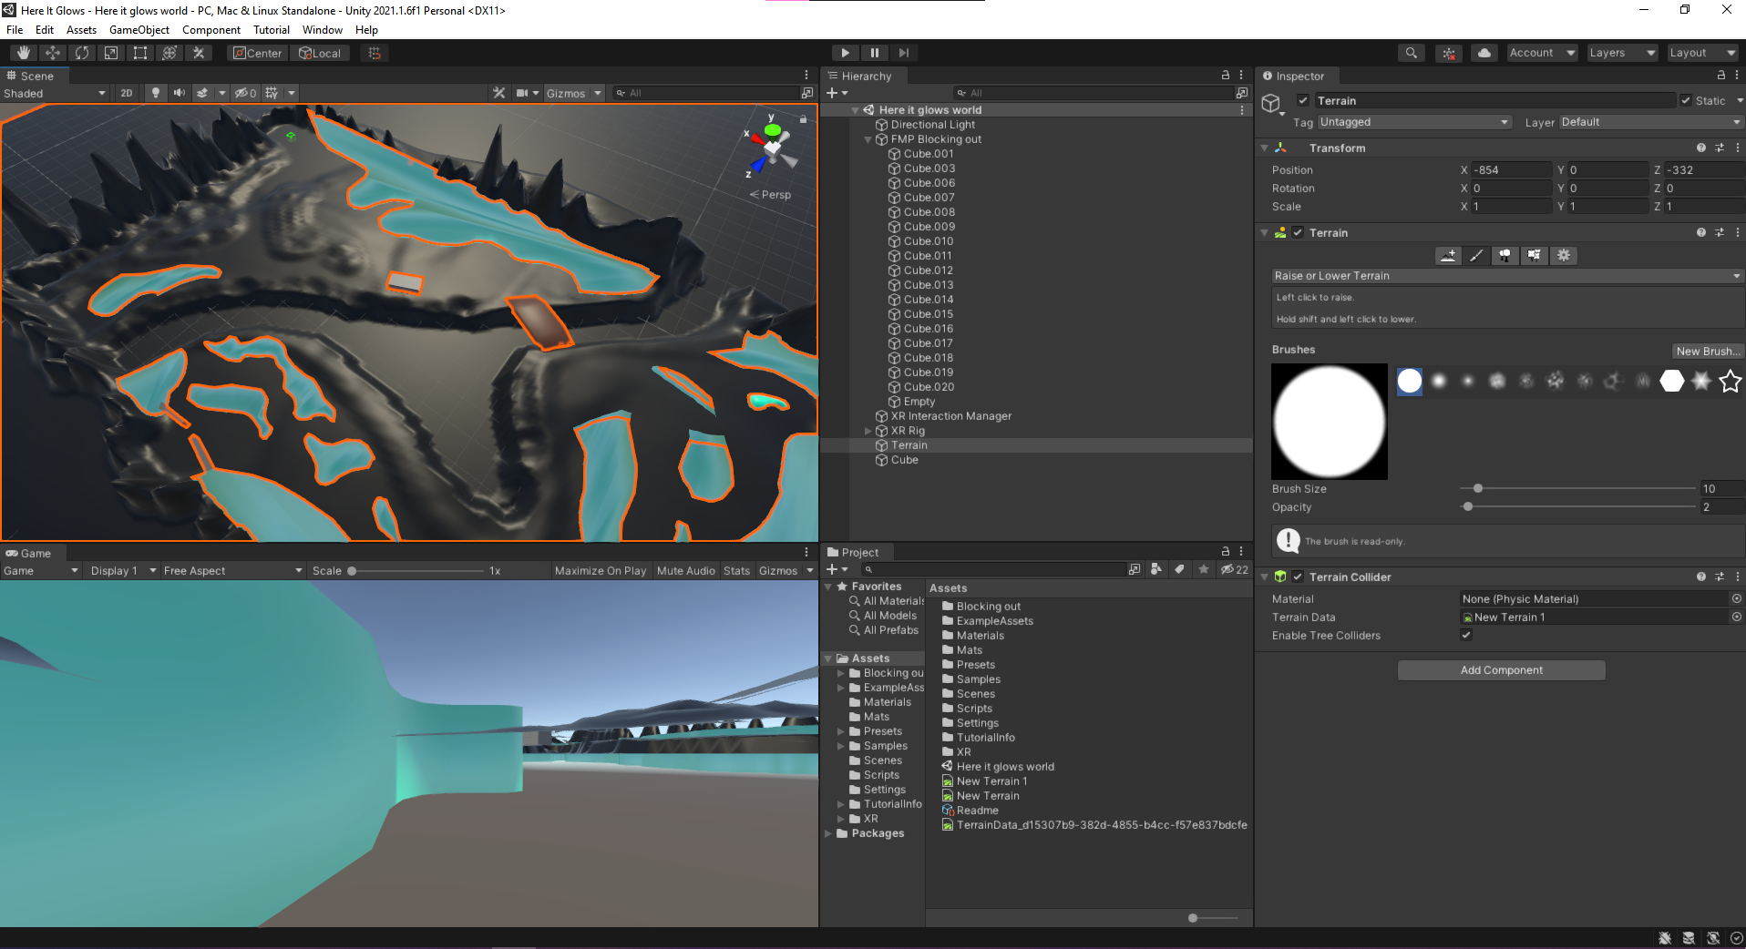
I had an idea to raise the land even more where all the foliage would be so the pathway is must more like decayed land. This also gives the world more depth to it. I did this by going around the placeholder for the foliage with the raise tool, then deleting the placeholder so I could fill in the centre as well.

19th May 2021

To give myself a break from raising land constantly I decided to make my grass blades and trees. I could have just used the grass blades I made before for the Unreal test I did but I noticed they were to chunky for what I wanted so I just made new ones. I made these in Blender.
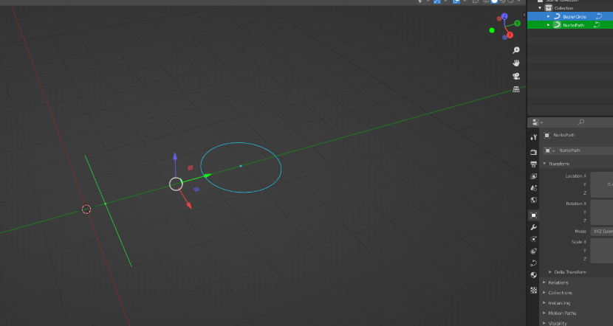
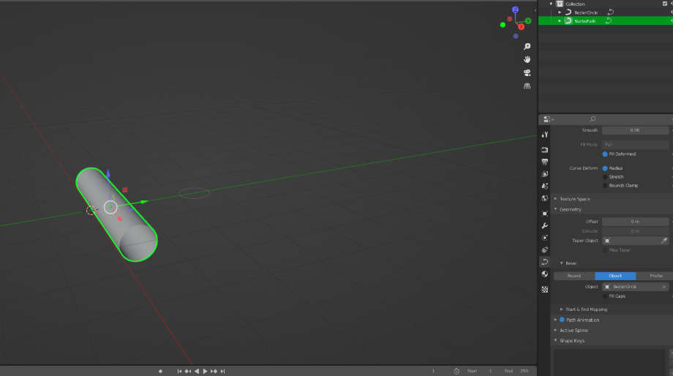
The way I make these is by added a path and bezier circle to the world. Make the path geometry the circle and then scale is down.

Then I scale down the tips in edit mode to give it more of blade look to it. I keep the tip which is going into the ground more expanded so then it does not look weird when it is in the ground. This also indicates which way is up or down.
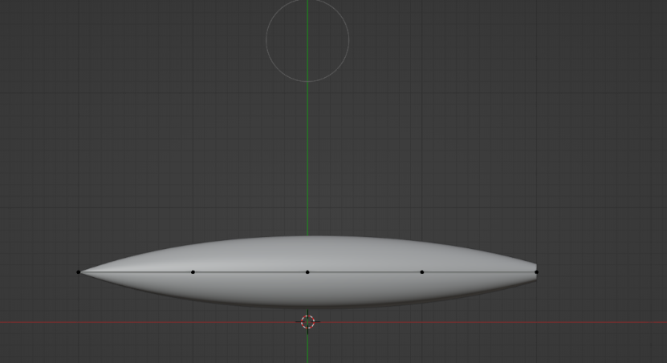

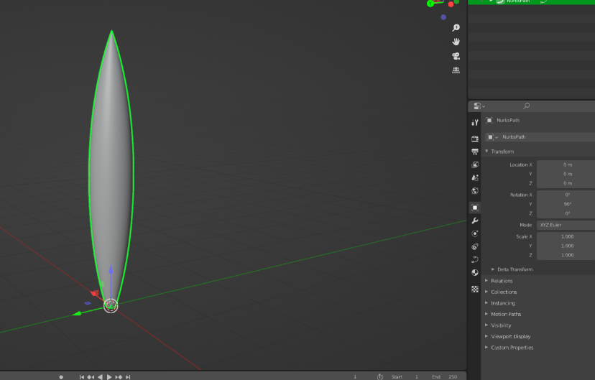
Once I have it like this I rotate it so it is standing up and change the origin to the 3D cursor so that when it is placed it will stand up from that origin.

From this I convert the curve to a mesh. Then I start duplicating and editing the blade multiple times to have different variety of grass blades.

Once I made four different versions and made my material. I know that it wont look exactly like this in Unity but this is what I will go for making it look like, to get a similar look I could make a gradient texture and then set the material as that.
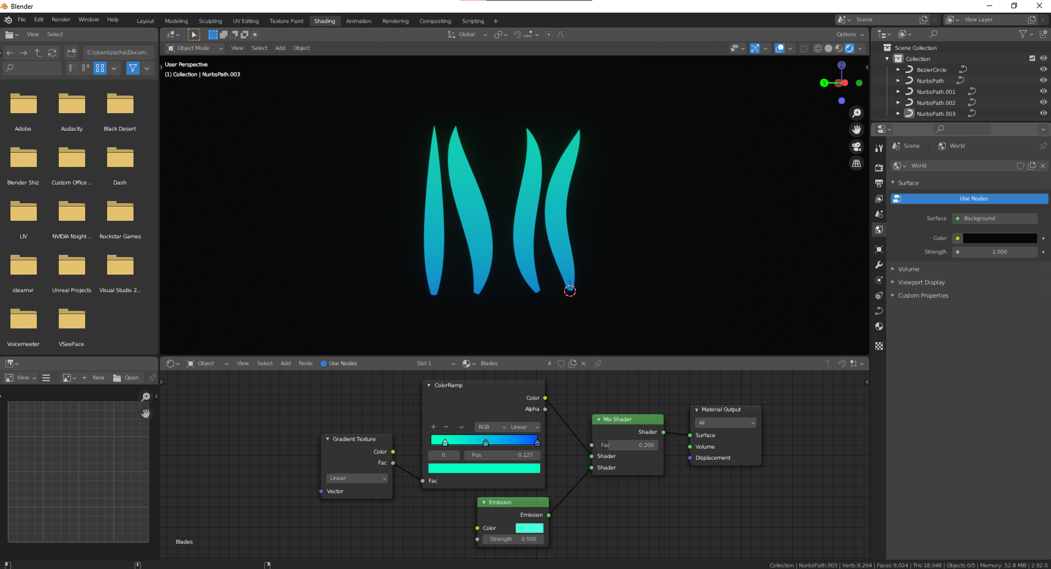

Once I was happy with my grass, I moved on to making my trees. These were done by using a tree maker plugin that is already installed on Blender. All I did was edit the thickness of the trunk and the number of leaves on the branches and I made a similar material as the grass one but went with more a blueish look this time. I am happy of how these trees turned out because the glowing blue on the black trunk gives it a lot of contrast.
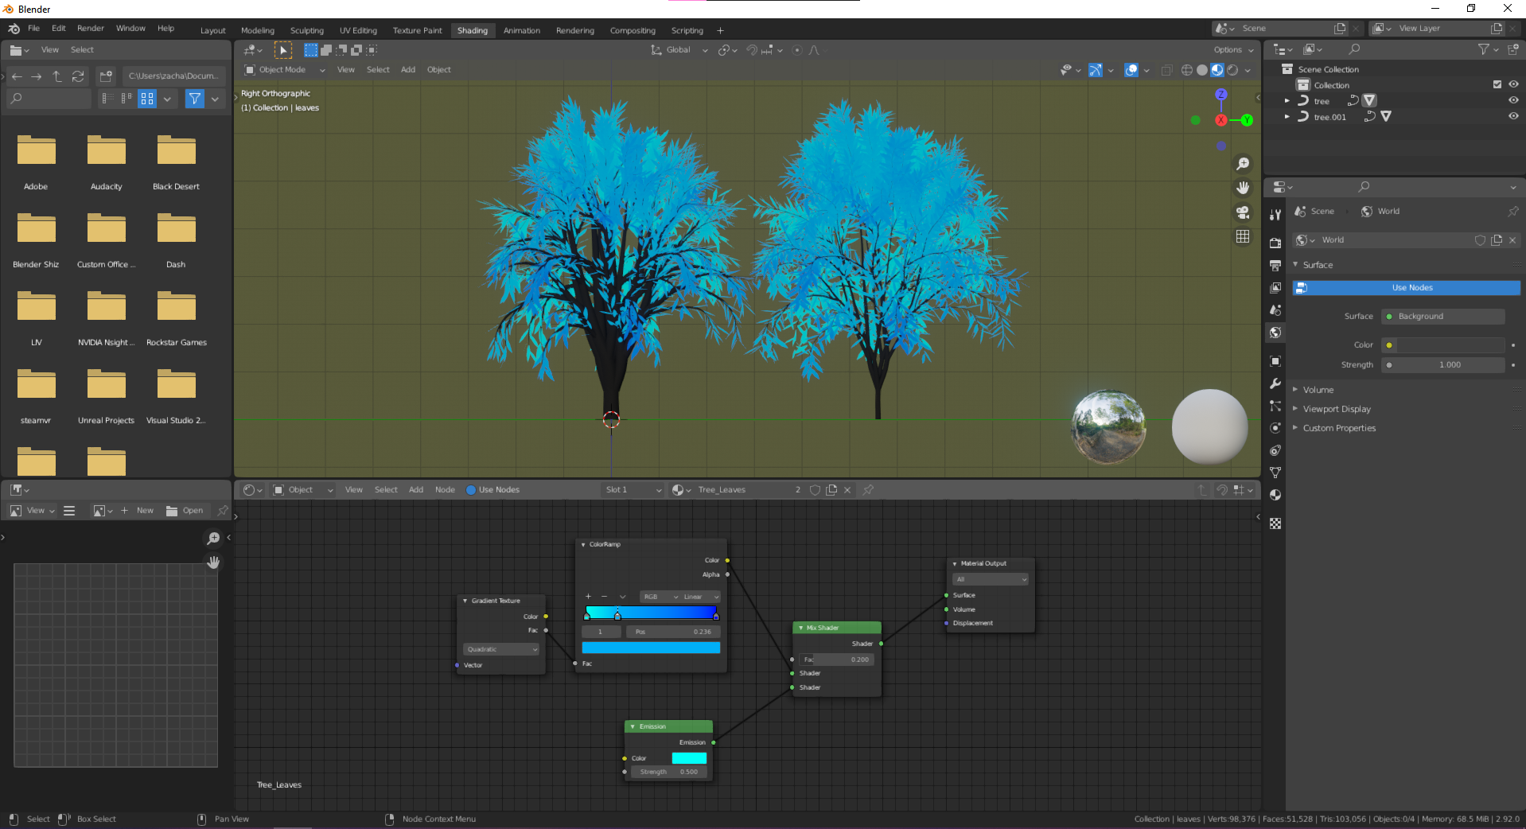

I still need to make one more tree that will have no leaves to make the world look scarier.

Noticing that I hadn’t finished my supporting evidence I spent some time on that filling in some of the subjects I needed.

20th May 2021
I spent some more on my supporting evidence to finish everything, with an included Survey.

24th May 2021
[The Crunch]

Looking at where I should be on my gant chart, I’ve realised I have fallen behind by a lot and currently have 16 days to finish of my game. With of how much left I have to do to finish my game, I will be lucky I can finish it in time. Right now, I am only at placing my foliage whereas I should be at making my third scene.

I know that the reason for my procrastination is due to me not being motivated enough to make my game. Realising that I put to much work on myself made me not want to finish my work. I still want to make to VR games in the future, but I know I am not able to do it by myself.

With the 16 days I have left, I need to figure out how to spread out all my work within these days.
I have made a sort of timetable with he dates from 24th May to the 8th of June to help me scale out the dates, by this last date I would like to have my game fully finished and packaged for upload. To help equal out time I would to be making my scenes by the 1st of June and be bug fixing the game by 6th of June. All my paperwork and portfolio upload will be done from 8th to the 11th of June because this is my final deadline for everything.

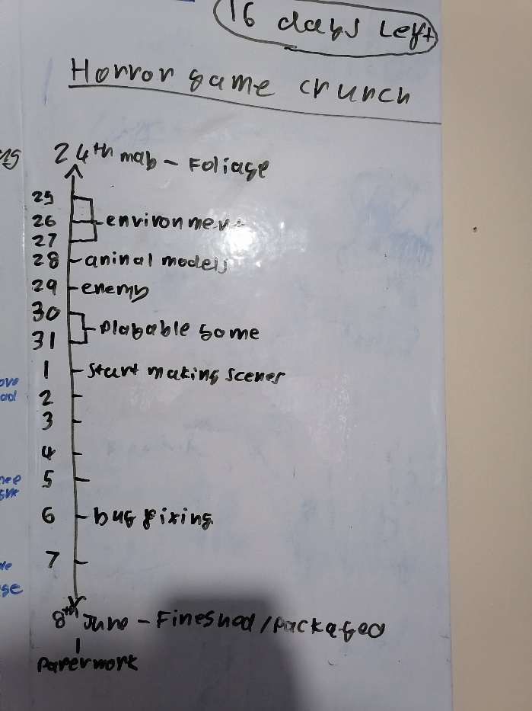
With the eight days I have until I want to be making my scenes, I need to finish my environment, model my animals, create the enemy, and make the game playable.
I think I am capable to finish my environment in three days, the animal models in one day, the enemy in one day (because it is just a shadow that is to scare the player), and two days to make the game playable as in being able to move around.
The time I have given myself for these tasks should be enough.

Getting on with making my environment. I added the grass models to the tree list on the terrain, I can use this like a brush and place the models where I want but when I was doing this I noticed that the model were laying down and not standing up.
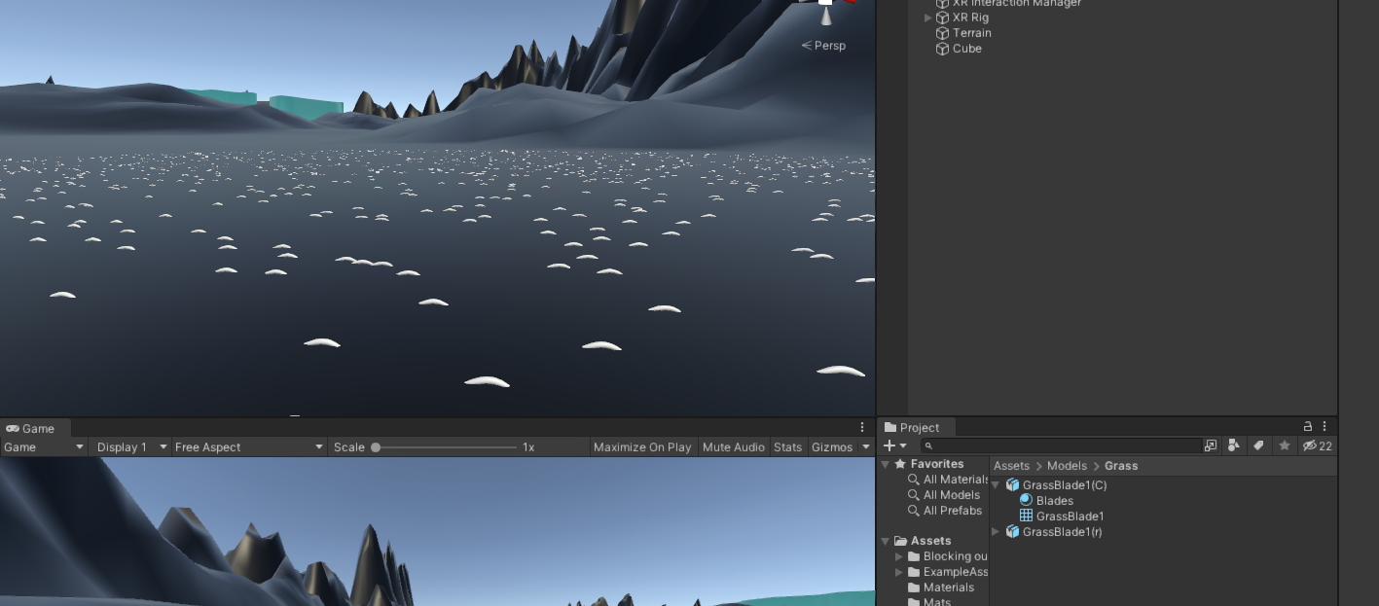
25th May 2021
I tried multiple times to fix it myself, but nothing worked. So, I looked up online for an answer to my problem but couldn’t seem to find anything. I searched up “Unity rotation from Blender” and saw the first video which told me to fix it and it worked. All I had to do was was stand the model in Blender and apply all the rotations, so they were 0, set the X axis to -90 and apply again, then set the X axis to 90. Export the fbx and it works.

Now I just have to do this for all four of my grass models.
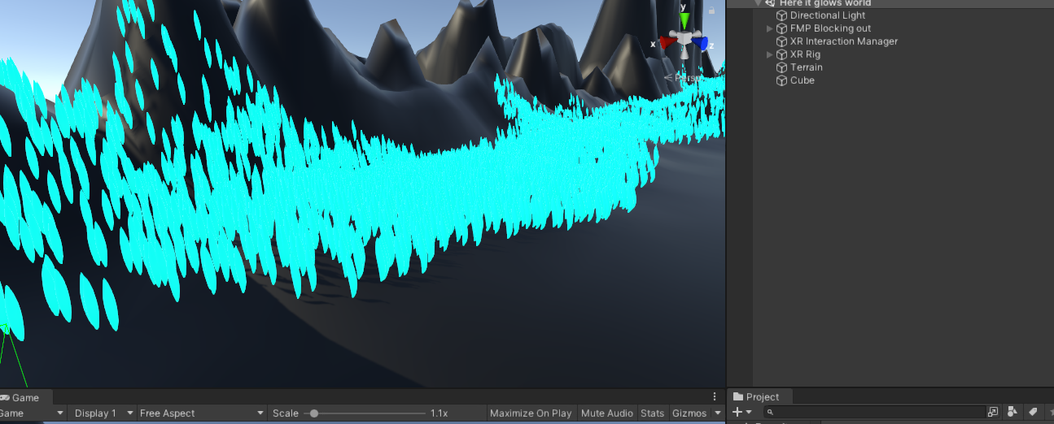

Starting to add in my tree models and I found out that the trees will not work with the foliage tool because the model does not have LOD group. So, I’ve decided to just place the trees manually. This also makes it so I can have more control of where the trees are.
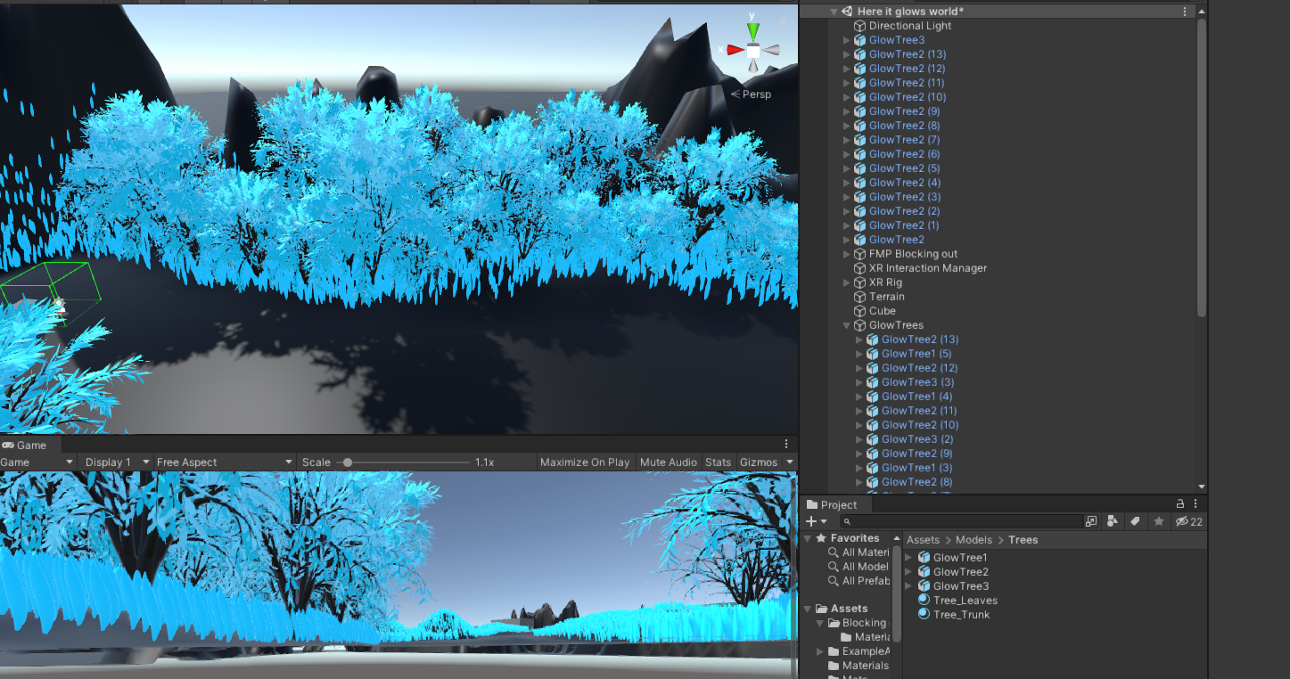
Messing around with the skybox material and making it so the world is at night-time to see what the foliage looks like now. Testing between Realtime lighting and baked lighting I found out that only Realtime lighting will put a shadow on the ground, which is what I want but this means it will take more performance for the lighting.
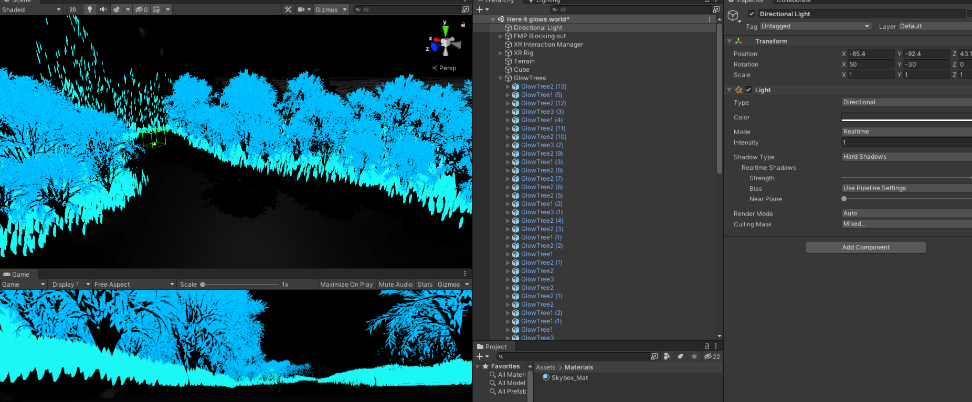

[The Wrong tool]
[Problem]
After placing all my grass down on the foliage areas. I noticed that the areas still looked odd on the black ground. So, I looked though the terrain paint tools again to see if there was anything that would draw a texture on the ground. There was one tool that I found that places textures but not what I wanted but then I realised that this tool was the actual grass placing tool I should have used. This new knowledge has made all the work I have done the last day useless because I need to do all over again with the right tool.

This will defiantly take a lot more time out of other tasks I still have to do but if I do it with the right tool It will help the performance and should look better. My grass models have to many vertices so I will have to add the grass using textures. For this I will have to take a image of each of my grass types, make the background transparent so its not a big white block.


Grass Blade 4
Grass Blade 3
Grass Blade 2
Grass Blade 1



26th May 2021

Using the right tool to place my grass is working so much better than it before. It is much easier to use, and the world performance is good. This is what the section of the grass looks like now with all four different grass textures.
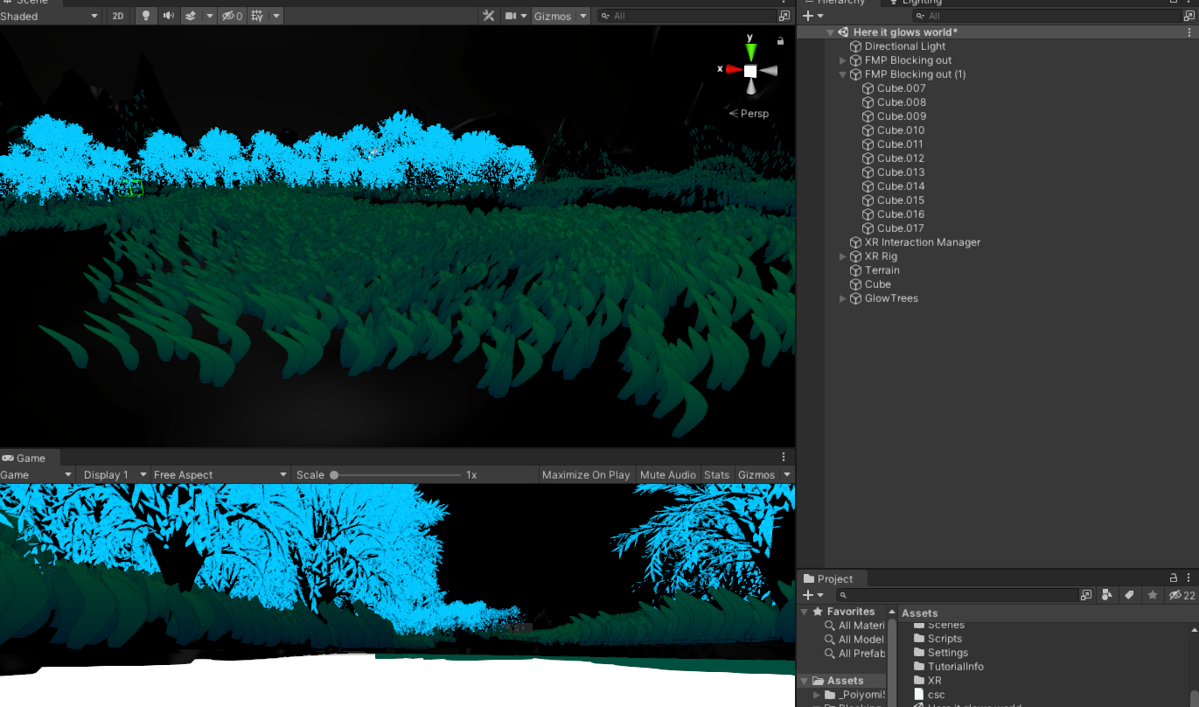
The only bad thing is that I cannot get the grass to glow like I wanted it to. I still think it looks and I will stick with this but if inn the future I tried this again I would try make it glow.

I spent a couple more hours on placing the grass in the right areas, I have decided that I am going to leave placing my trees till later. I will do after I have made my bridge and gates because then I will have them out of the way, then I can just focus on the house and the trees for next day.

Moving on to making my bridge I started just making one and made what looks like an abandoned bridge that would be made of metal, but I realised that because my environment is a forest, I should go for one that looks like it is made of wood. A wooden bridge would look much simpler and better in its surroundings.

Going through making my bridge I thought of three different designs which I found online.
The first bridge has fenced of sides blocking it so the player cant walk or jump over. The second bridge has one rope that is blocking the sides. The third bridge is the same as the second one but with 2 ropes instead. I like all three of the designs but because my game is a horror I want to go for something that could look old and worn down.
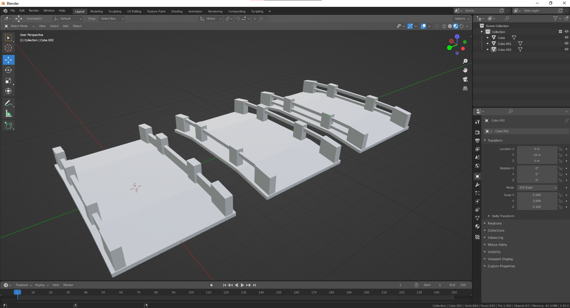

I am going to go with the third one because I feel it fits more with the atmosphere. For the material I am going to use the brick texture node but make them look like planks of wood.
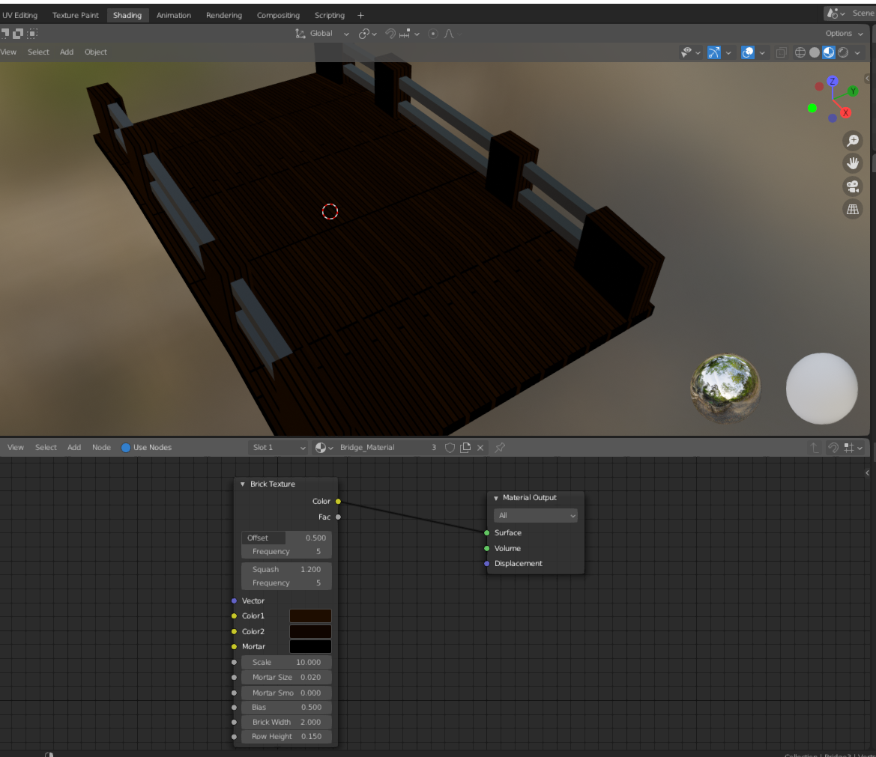
This worked better then expected and looks pretty good.

The Texture I made in Blender didn’t transition over to Unity so to fix it I’m using a seamless wooden plank texture I found free online. I also made a normal of the texture using a program called Materialize. This is what it looks like placed in my world.
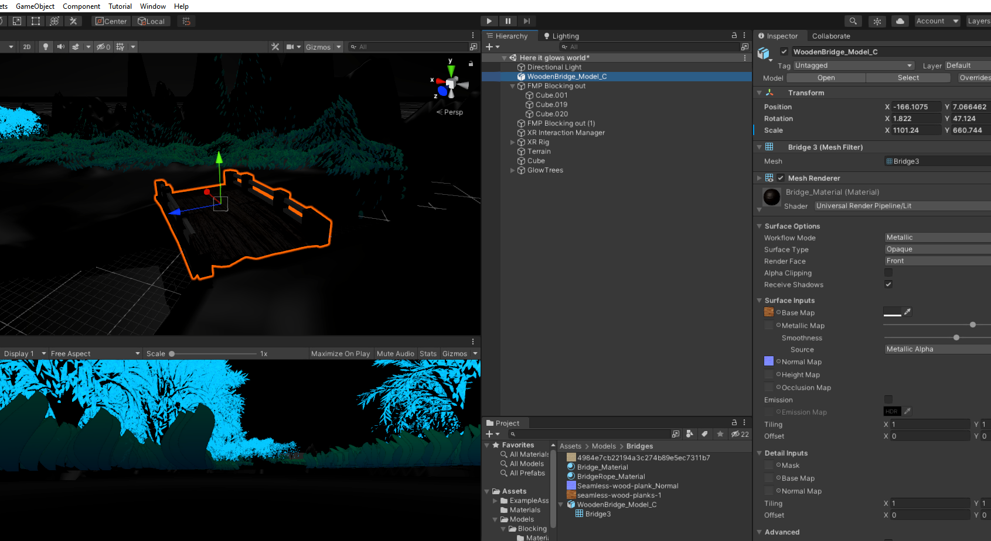

For the gates I am going to make my own metal fence texture I put it on a plane. This is so I don’t have chunky gates but still have collision.
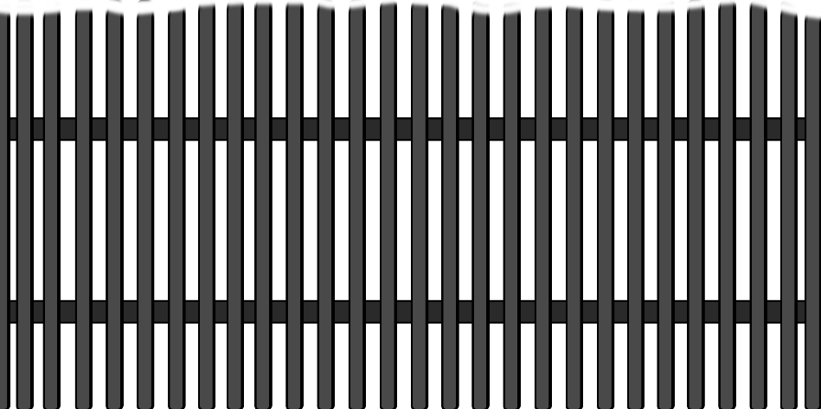
This is the texture that I made. I added some depth to it by duplicating everything behind and moving a couple pixels over.

I erased some of the top to make it look less blocky.

The gates are placed to block of the exit to the player. Looking at the surrounding, it looked to bland with nothing around it. So, I decided to model an escape tunnel that is not just a normal cylinder. To finish the game the player must walk into the tunnel rather than just the gates as if it was a sudden ending.
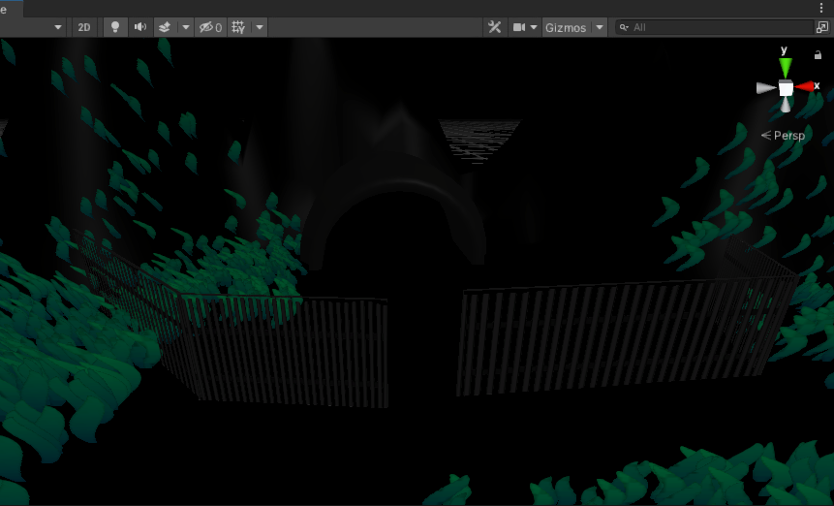

Looking at my schedule again getting all my models done in a row is more time effective and should hopefully give me an extra day later. So, in the next two days the tasks I want to have done is the house, river, animal models, enemy, and the rest of the foliage. The house, river and animal models should not take more than one day. The way I am going to make my shadow enemy is by using transparent oval object with a smoke particle effect on it. This is just for the scenes where you can see the shadow.

I forgot to take screenshots of the journey I did to make the house, but I can say it as simple as possible.
I added a cube to the world and subdivided it so it would give me a line in the middle of the roof, I moved that line up to make it look more like a tent. I extruded the roof up a bit so I can extrude it out again to make a lip around it. Like this image.
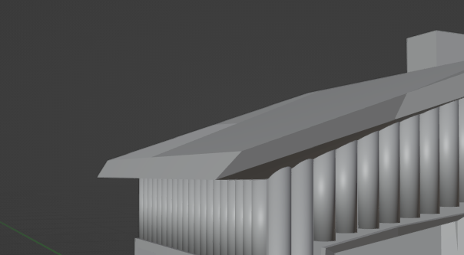
Now I went on with making the door and windows. I realised that because I moved that line it has messed with the mesh so when I try to subdivide again it stays at an angle, but I think that made it better because it matches with the shape.
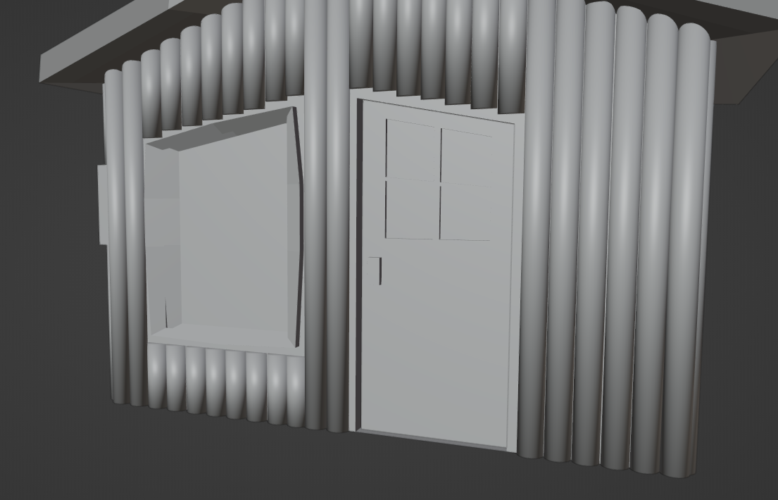
Now with them done I have more sense of the shape of the house, so I began adding the cylinders are around the outside as if they were logs. This took the most because I had to keep on duplicated and edit the height of them to match the walls. I like of how it turned out because it looks similar to a wooden cottage which is what I was going for. I could have gone with making a big house because I do have the space in the world, but I did not because I knew wouldn’t have fit well with its surrounding.

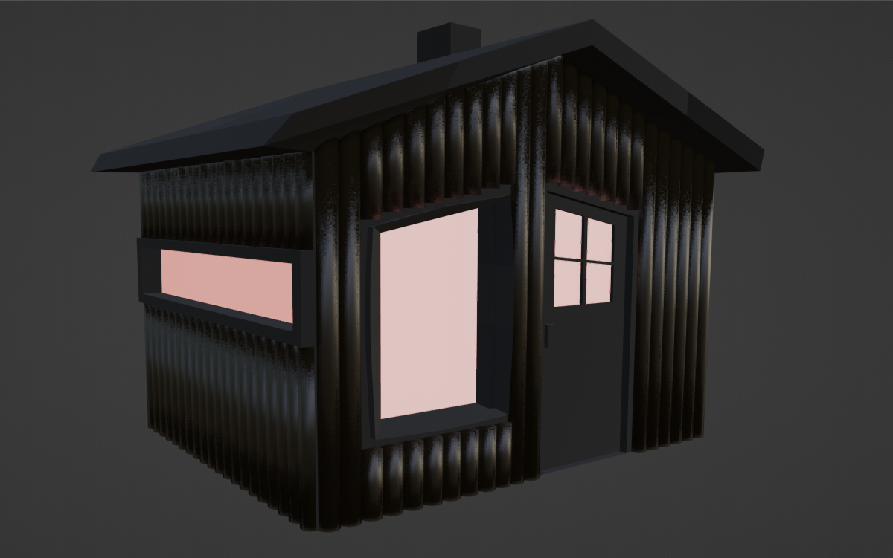
Here is what It looks like right now in Blender with just plain materials added on. When I import the model into Unity I will add a wooden log texture to make it look more realistic.
Here is what it looks like when imported into Unity. I also made a normal texture for the logs and because emission on material isn’t strong enough to reflect lighting on other object, I added in two separate point lights to do this job.
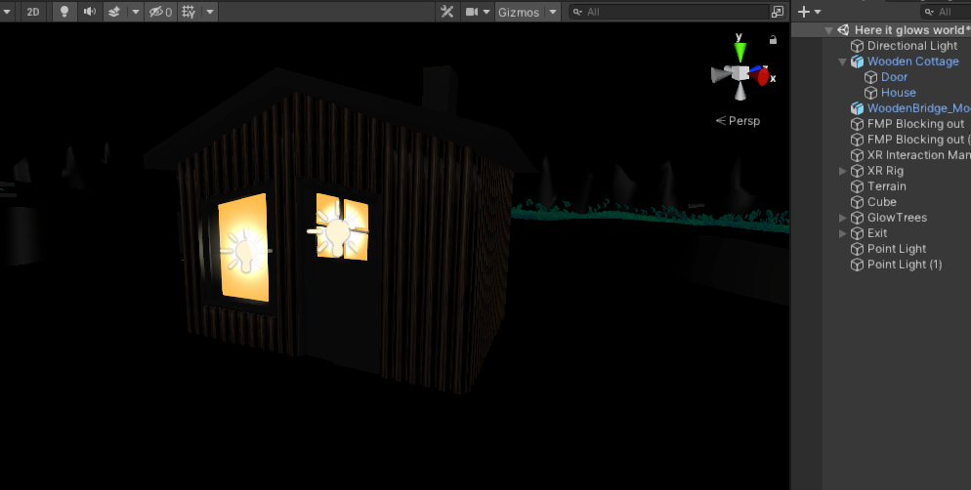

27th May 2021

With the house done I am going to move on to making my water for the river/lake. Because I do not really know how to do it, I’ve looked up tutorials online on how to make a moving water material. I found one that was made by the Unity Dev YouTube channel that shows how to make moving water with a shader graph.
The video is very complicated and does not go into what nodes do when connected to other nodes. But here is the link (https://www.youtube.com/watch?v=gRq-IdShxpU )
If I did have more time then I would have liked to learn more about it but because of time constraints, I have got to keep doing my work. Since my world is dark, I can’t have my water being too bright, but it could work if I have the edges glowing like Bioluminescence algae in real life.
28th May 2021
I have decided for my animals I want to make them in my own style, this is because I feel that making the animals look as realistic as possible would not fit in with the world. If I also used the idea of having everything luminous, this could also work with the animals by having the firefly all Orange and the Tomopteris as all blue.
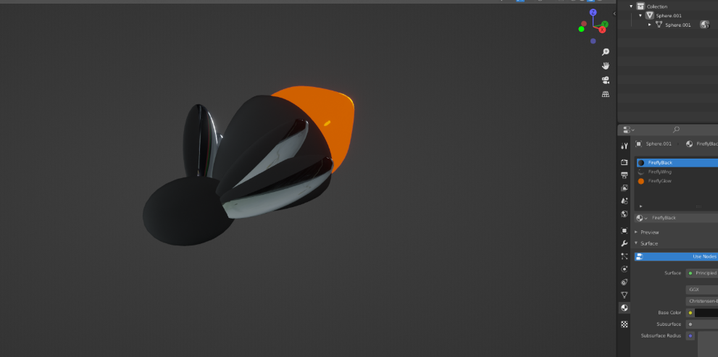

Here is the firefly that I made. It was done by just using a sphere and making it more like an oval shape and attaching another sphere to that for the head.

31st May 2021
[Mega Crunch]
Currently I only have 7 days to finish off my game. To help me finish it on time I am going to make some cutbacks to make sure that I finish the game and have a finished product to package up. One of the cutbacks I am going to make is not making the Tomopteris, this is because making the model will take too long, and that time should be spent on making the game work like a game.

Another cutback that I am going to make is changing from 4 scenes to 3 scenes. I will be joining scene three and four into one. That means it will make the game a three-act structure rather than a “kishōtenketsu” which is a four-act structure story used by the Japanese.

Right now, on my new plan I should be making my first scene but because I was busy doing other stuff I did not have time to work on my game, this puts me two days behind schedule. To help me catch up I will be condensing some of the tasks into one day. Today I will finish off placing all my trees in the world and making the game playable, tomorrow I will be making scene 1 and 2. The day after will be the mix scene of 3/4. If I finish scene 1 and 2 quickly, I may get the other scenes done at the same time. Special effects and the menus, titles will be done in one day so that hopefully by the 4th of June my game should be ready to be packaged up and put onto itch.io, for people to be able to download it. Whilst I am doing my special effects, I will also add the fireflies and flowers to the world. These are to help guide the player to the exit in the game.

Now with my plan all set again I should get on with getting this game finished.

Here is what the world looks like with all the trees placed. I noticed that there is a lot of blank spaces so ive decided to add in more grass patches and trees.
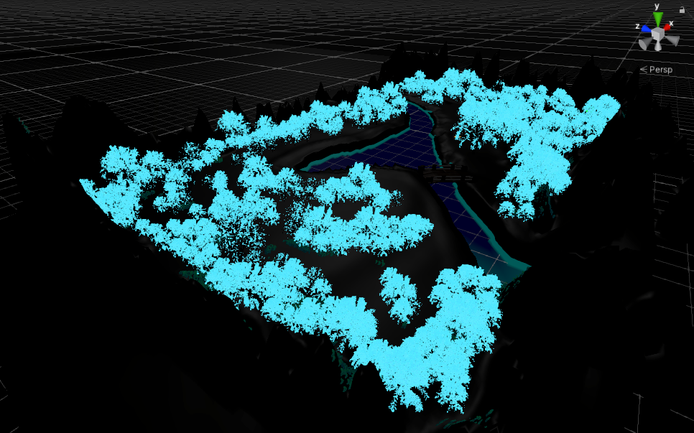
Here are some more pictures in the world.
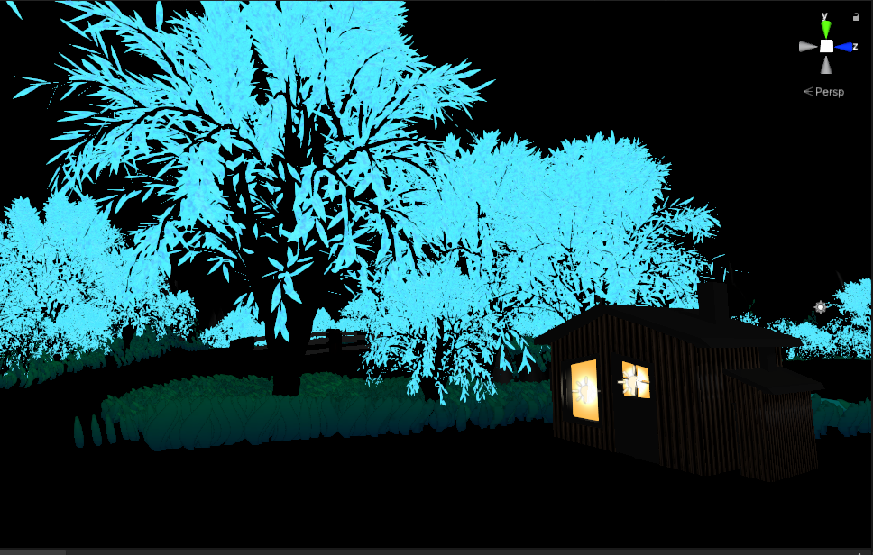
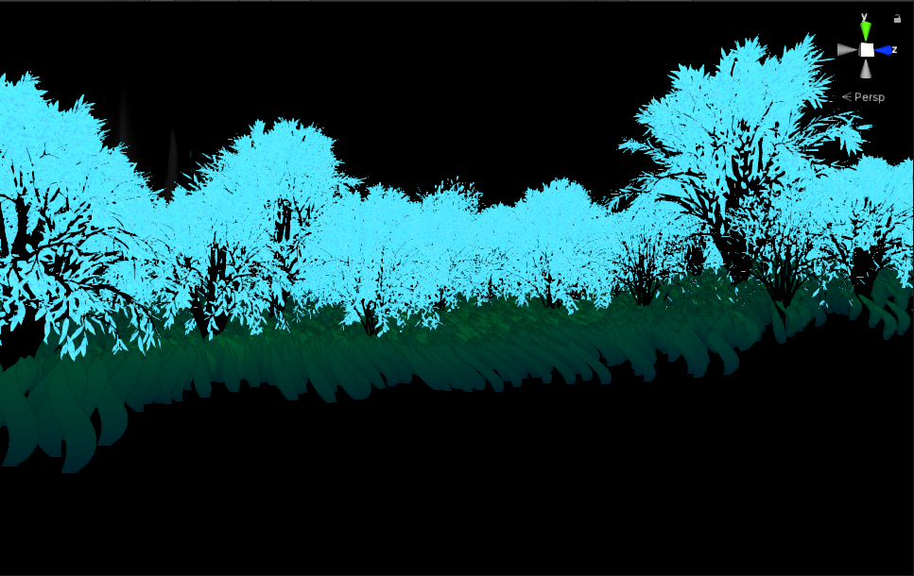
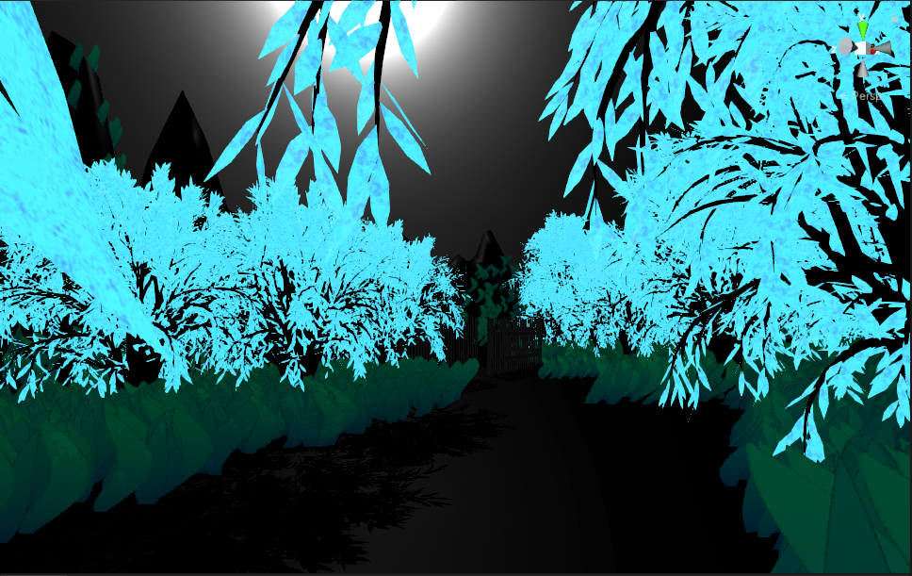

Messing around with the lighting I found out how to enable the fog.

1st June 2021
Now with my environment mostly finished I can start working on making the player being able to move and turn. I don’t have enough knowledge of doing this yet so I will watch some tutorials to teach me how to do it. This will be more complicated because my game is in VR so the controllers will be different.
Looking at some of the tutorials to set up movement and turning it is easy by just adding two components to the XRRig that make it so I can continuously move and continuously turn around. There is an option if I wanted to use teleportation locomotion but because I want the player to feel immersed in the game , I am sticking with normal movement.

[VR Horror Game Test Vid]
Once I had it all setup, I decided to do a test and record it. I do like the way the environment looks and the way that the grass sways but from testing some of the things I found out:
- The Bridge didn’t have a collider.
- The Cottage didn’t have a collider.
- Because the depth of the water goes off the Headset camera position the glowing part rotates which does not look good for the player.

Some of the good things I found out from testing was:
- Grass works and can be traversed.
- Trees have colliders so player cannot walk through them.
- Ground reflection works like I want it to, specifically the shadows the tree leaves produce from the moonlight.
- The terrains hills do not mysteriously block my way.

2nd June 2021

With only 5 days left for me to finish my VR game and have it all packaged up and ready for upload. I still have four main tasks left to do, so I am going to switch my tasks around to make my time more effective. I should be making my scenes but because most of my scenes are just events, I am going to do that after I have done my special effects which is just adding my flower that guides the player and my fireflies.

I already made a bundle of flowers but looking at them again, I do not like of how they look so I going to remake the flower, but this time make it better. The idea is just to have a glowing red/pink flower (similar to a rose) that shows the player where they should be going symbolizing a beacon of light.
It is to help the player know that they are going in the right direction, so they are not going around in circles.

Whilst I am making this flower, I may also make some water lilies for the river because I was not able to do my tomopteris animal model. The river looks empty right now and I feel this would help that. If I did do the water lily, I would have that as pink and the rose as red.

This is the first try I did at making a Water lily on a lilly pad.
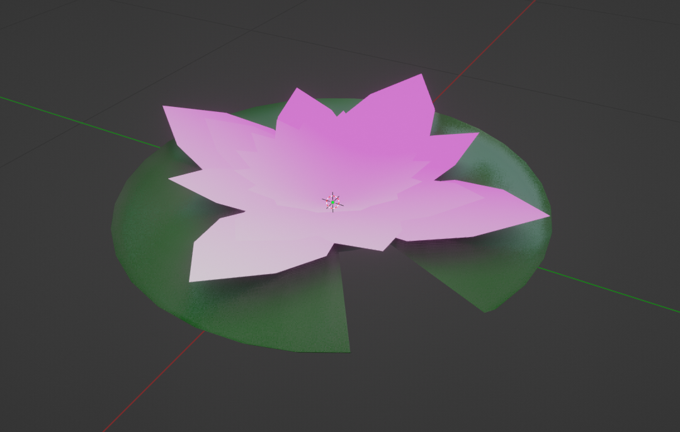
I really like of how well it turned out.

I made the base flower by turning a plane into a hexagon shape, scaling it down and then duplicating multiple times in a circle. Different levels of the flower have different number of petals and are at different angles to make it look more 3D. The first layer has 4 petals that are at Z 90º apart from each other and Y 15º from the bottom. The second layer has 8 petals that are at Z 45º apart from each other and Y 20º from the bottom. The final layer has 16 petals that are Z 22.5º apart from each other and Y 30º from the bottom.
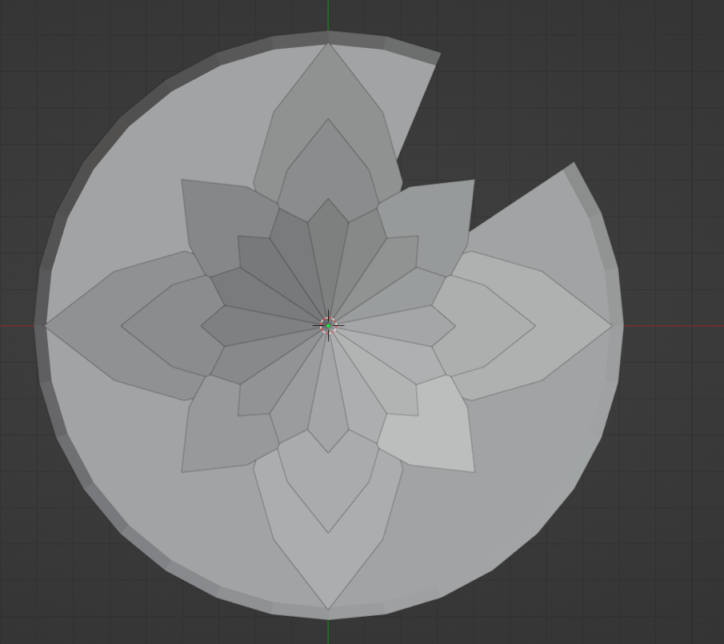
I also made the lily pad be adding a circle. Extruding the edge up to give the curve. Then delete some of the squares to make the cut in.

I could also use this is flower head again for the rose but just make it smaller and give it a stalk. I could just do this simply by using a cylinder but because I want it to look more like a flower. I am going to use a Bezier path so I may the stalk curvy.
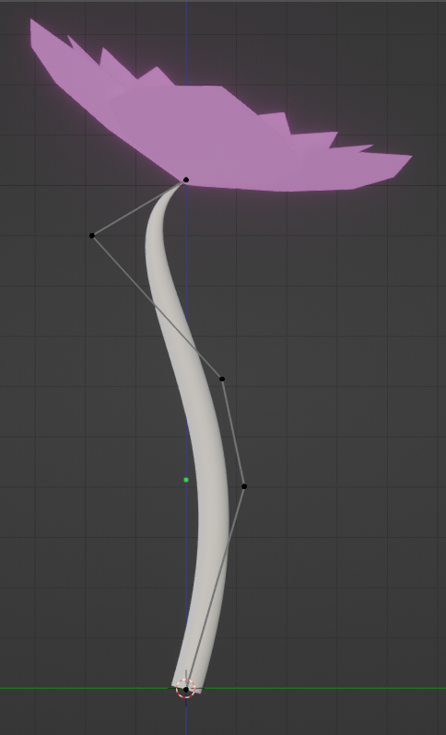
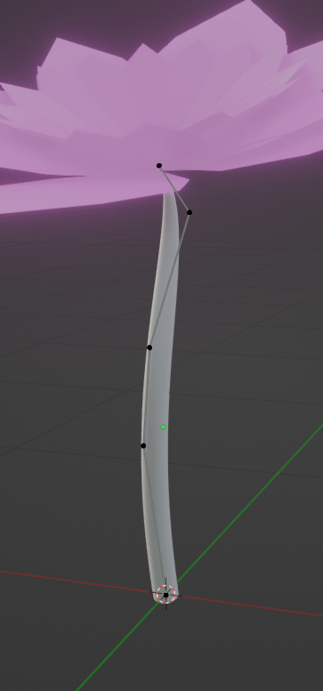
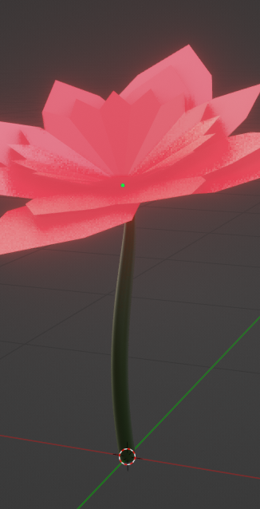
I know that the river movement will make it so the water ends up covering the lilies, but it will still look like I want it to. If I had more time, I would add a rotating animation that looks like the river is moving the lily up and down with the current.

Here is a picture of what the rose flower looks in the world. The flower head wasn’t as bright as I wanted it so I added a point light source to make it brighter.
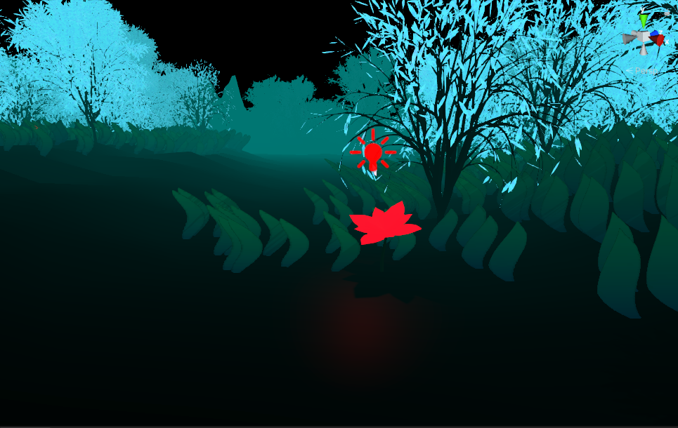
All together I added 16 rose flowers to the world along the pathways. 6 of them are at the exit to show that the player is safe.
And here is a picture of the lilies in the river.
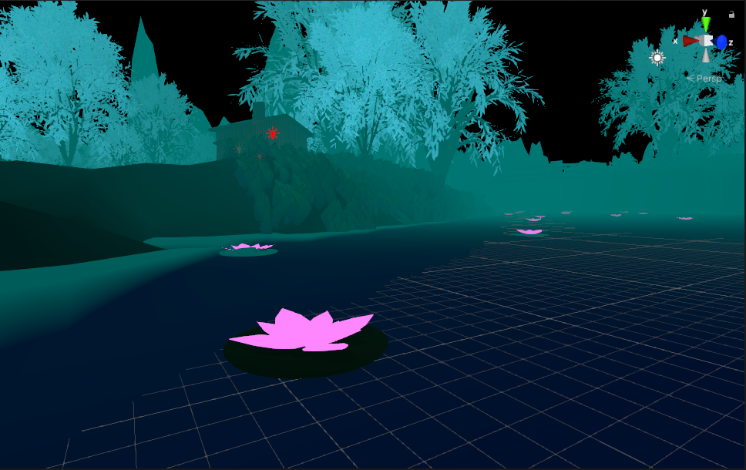
I can’t figure a way to implement the fireflies because I was going to use the fireflies to guide the player but now the flowers do this. I think I am just not going to use them because now they have no purpose except just for looks.

3rd June 2021

Starting to make my starting screen, I first went into making the title because I hadn’t designed one yet. The name of my game is “Here It Glows” I thought of this name because of how my world is a place that glows. If I had more time to make my title, I would have really wanted to drawn it out by myself because then I would have it as I imagine it. So instead, I am going to use Adobe Illustrator to make my title as close to what I want.
Messing around with multiple fonts here are some of the designs that I have made so far.
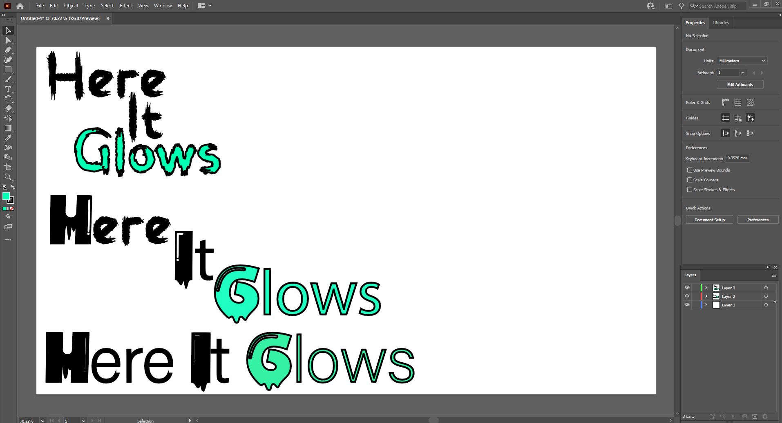
So far, my first one is my favourite because it fits in with the horror style. The second and third one look ok but I feel like if someone saw it for the first time, they would not see it as a horror game name.

Here is a base idea of what I want my menu to look like. The background will also be Black.
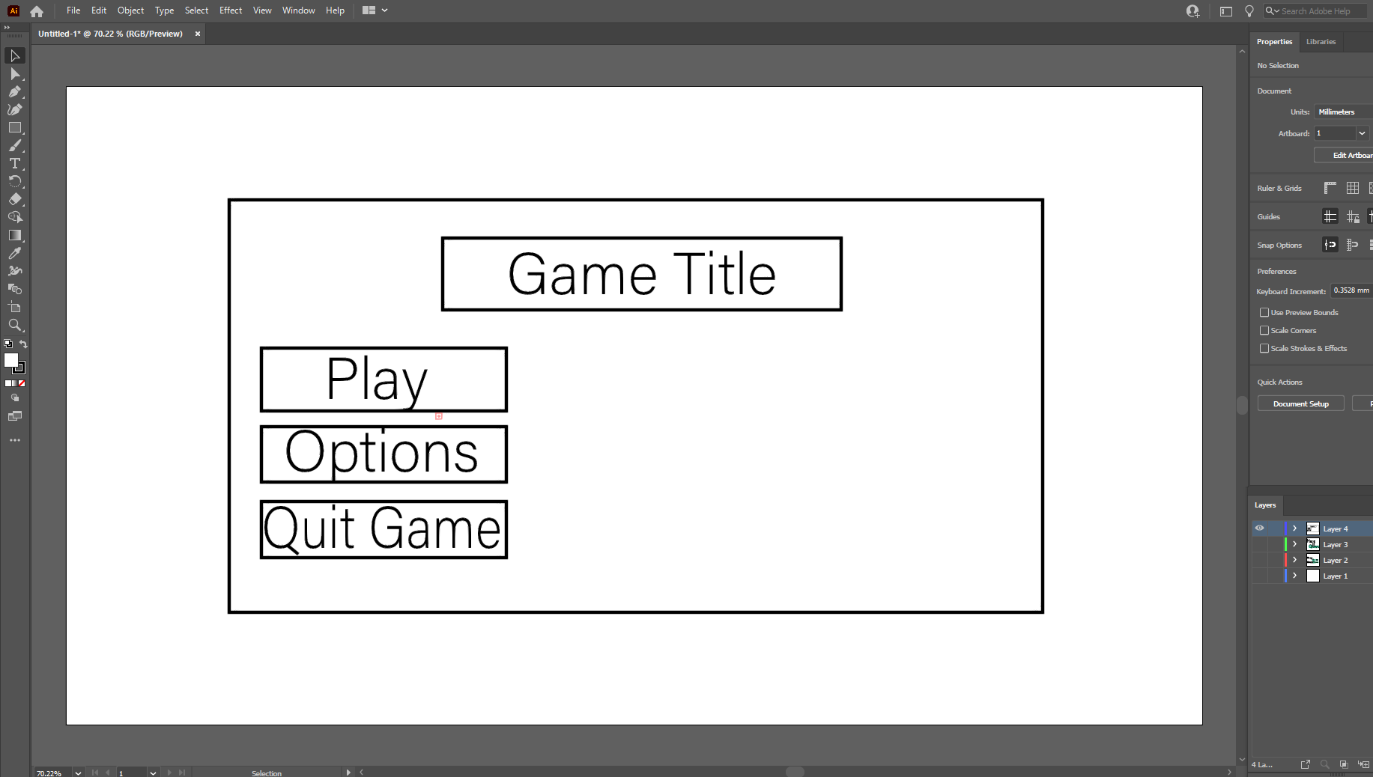

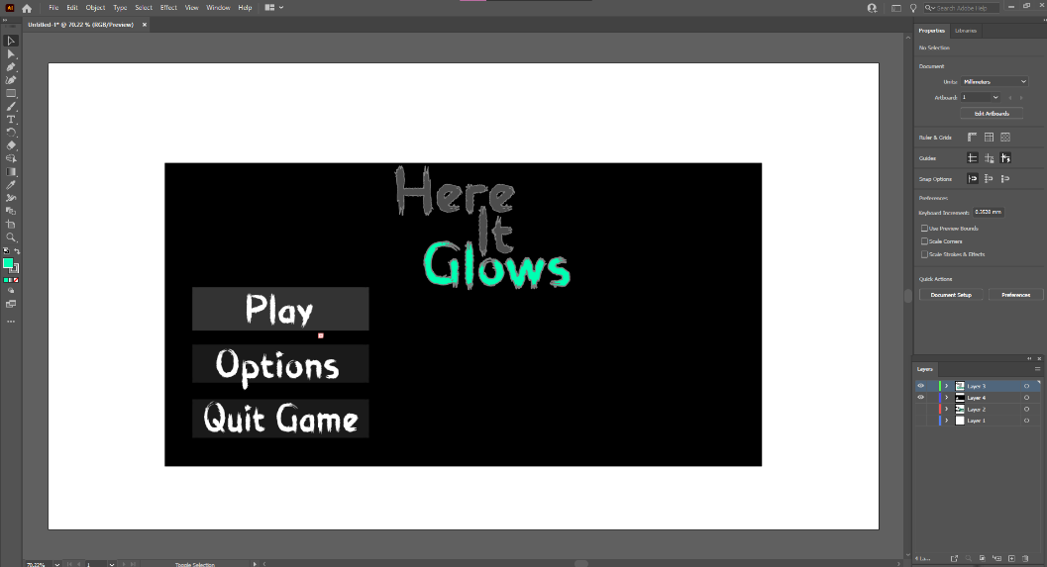
Arranging more of how I would want it to look like this is what my second version looks like.

Transferring this idea over to Unity would be easy because I can just use plains and buttons.

Here is another version of this version but with green outlining.

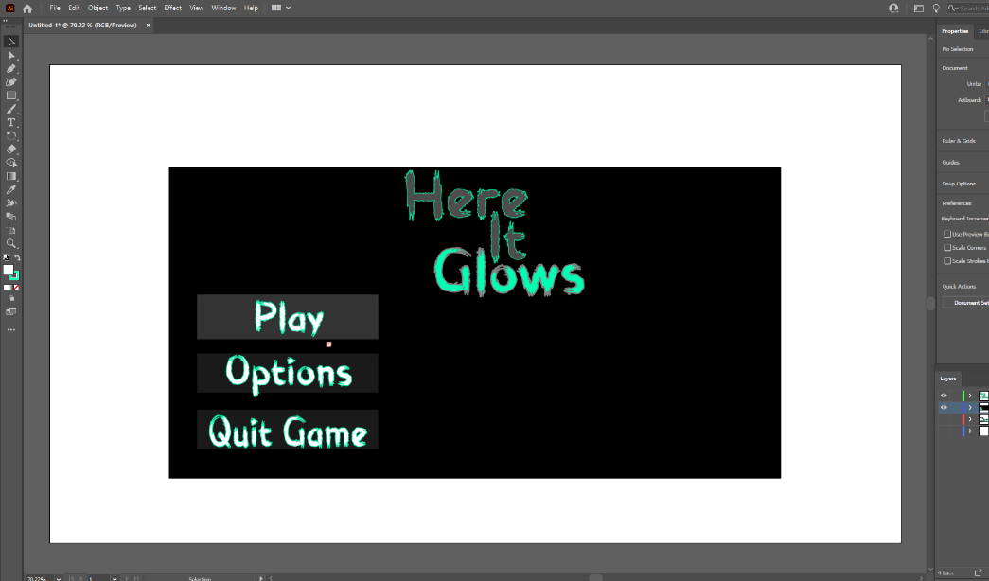

I can either make my menu in 2D or 3D. If I do it in 2D I can just make it simple like this. If I did in 3D, I could add the grass and trees around player to show them what it looks like before they start to actual game.

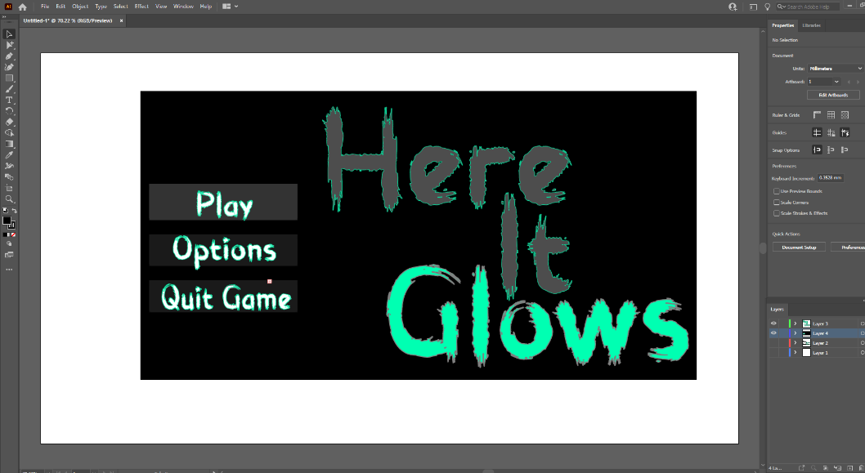

Here is another version.
with a bigger title to the side of the buttons. I prefer this idea, but it may be to in the players face if I did this in 3D.

Making my Starting screen was a long process watching multiple tutorials because making a menu in VR isn’t as easy as I thought it would be, but this is what I ended up with as my finish starting screen.
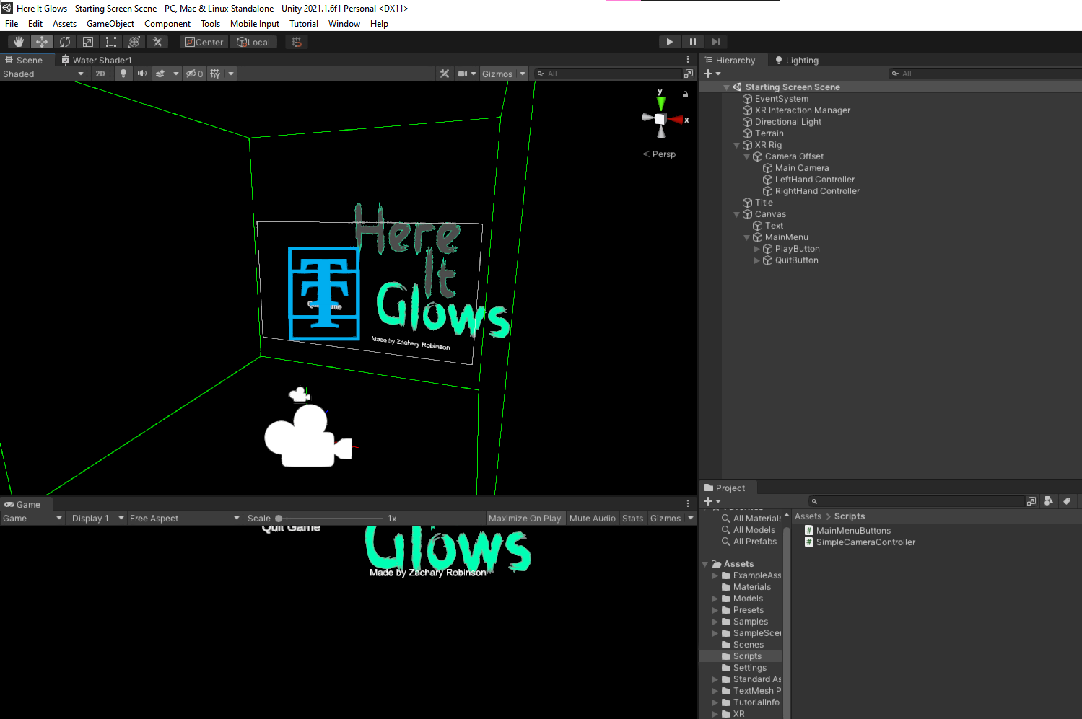
I have done a “Play” button to start the game and a “Quit” button to quit the application. I was going to add an options buttons for settings, but it would take too long.
With that menu now done and the Ending screen done. The ending scene is just a plain of text thanking the player for playing, with a quit button below it to close the application. I can now go on to making the smaller details of the game and the main story scenes.

Looking into how to make working hands for a VR game I have decided that I’m not going to add hands because I want to focus more on the horror aspect of the game. If I added more interactable stuff to the game than I would have added hands. Like my old scene 2 where the player would have opened the door and been able to hold objects in the cottage. The only thing the player will interact with in the game now is the note at the cottage.
Not making and setting up hands will save time that can be spent on making my scenes better.

4th June 2021
With only 3 days left to have my game done by I am running really low on time. All I currently have to do is make my story scenes, making sure that it all works and then package it up.
I have also updated my FMP Story word document to the updated story. I have left the old story on the document so people can read the different I made between them.

5th June 2021

One thing I totally forgot about with planning my game was the sound. But because it is just a forest, I can just find a free forest environment sound, use that and if I feel it does not fit then I can just make the sound deeper with a music problem like Audacity.
I will have the main sound going through the entire environment and throughout the pathway I will add crow sound effects to scare the player.
Here is where I found the forest sound effect (https://www.zapsplat.com/music/ambience-ambiance-ambient-forest-nature-florida-woods-wild-grass-outdoor-trees-day-dusk-loop-seamless-looping-wind-windy-breeze-debris/ )
And here is where I found the crow sound effect (https://www.zapsplat.com/music/crows-many/ )

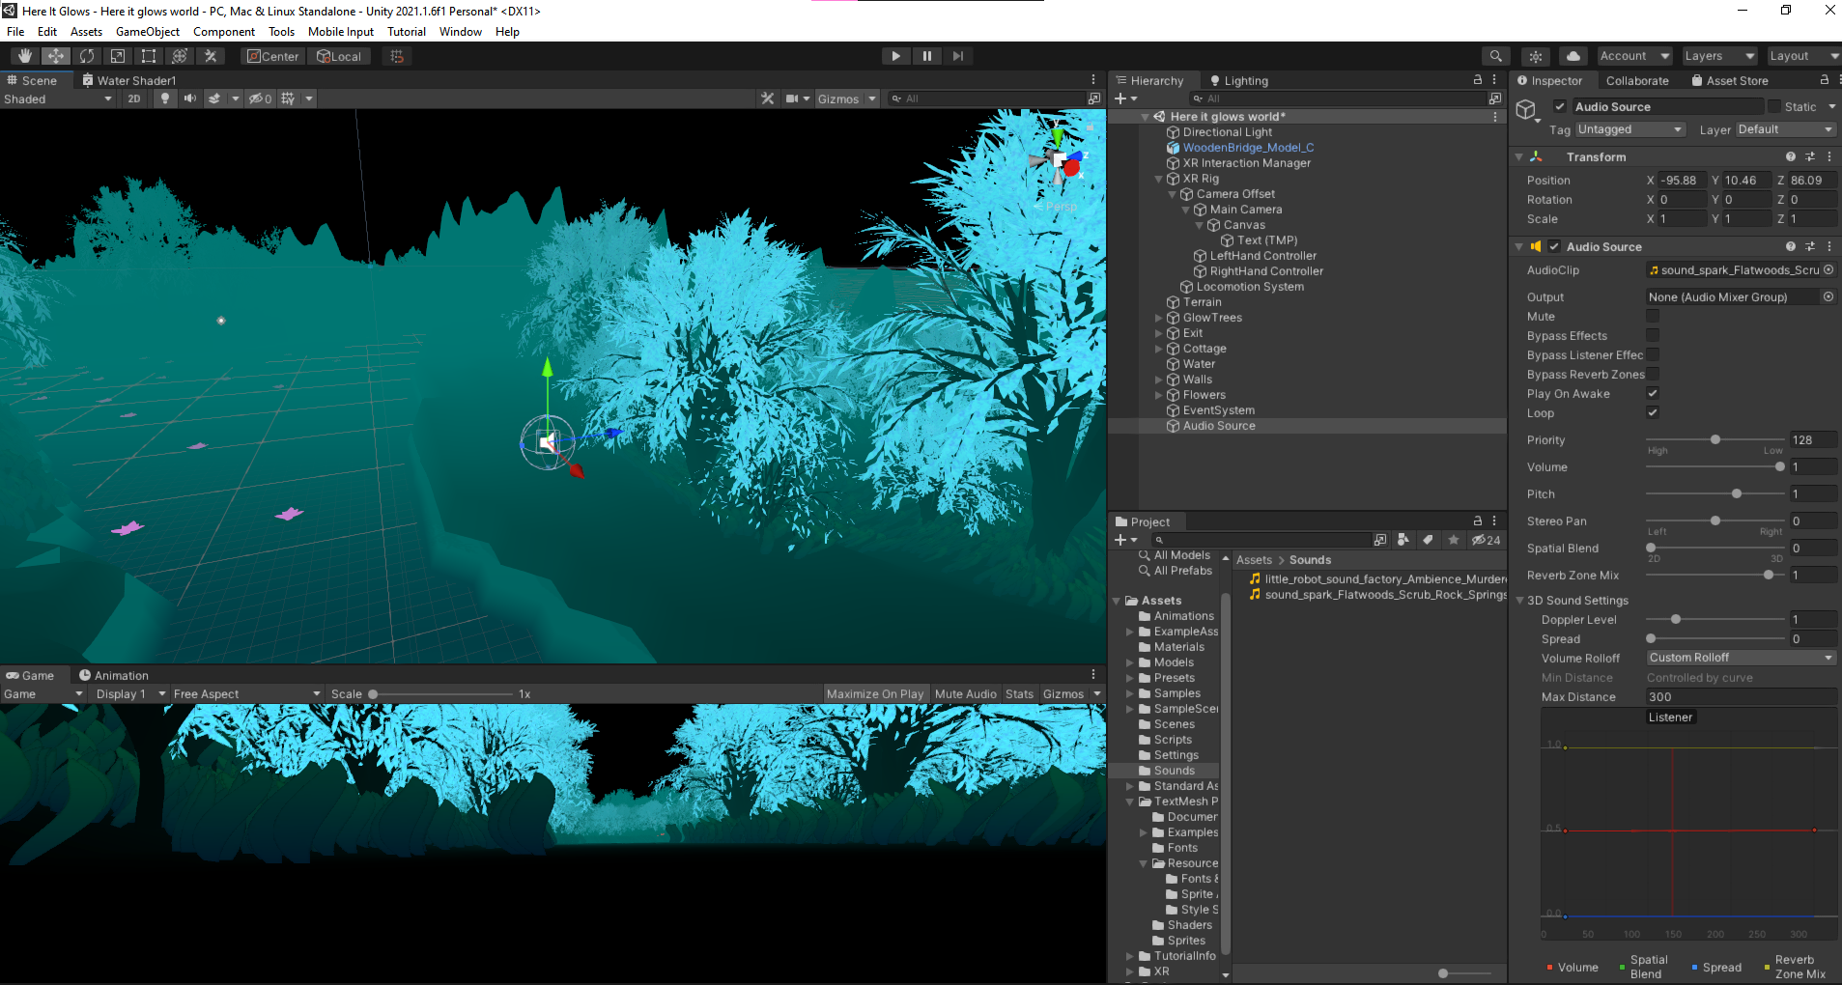
For the forest sounds I can just leave it on a loop throughout the gameplay because then it is a constant sound going through the map. For the crow sound effect, I want them to play on triggers so when the player walks into a collider the sound plays. I have learnt the basics of how to code in C# so I am sure I can do this by myself.

I have put the first trigger by the cottage. The second trigger is over the bridge so the player doesn’t take a shortcut and the third one I will put just before the exit.

I have also successfully placed a collider trigger at the exit that opens the third scene which is the Ending scene.

Currently my game has a start and an exit that works. I still need to add in the note that tells the player to go to the exit. So really my game already works and could be packaged up but I’m still not finished with some tasks so I just need to add in final touches to the game then I can package it up.
I have done the bridge scene and added in the shadow that disappears when the player walks into the trigger at the start of the bridge. For the shadow I used a sphere and made it 3m tall, so it looks like a shadowy figure. For its material I set it as grey and set the alpha to 70% so the player can see through it but can clearly still see it. I gave the Shadow a particle system, so it has what looks like smoke coming of it.
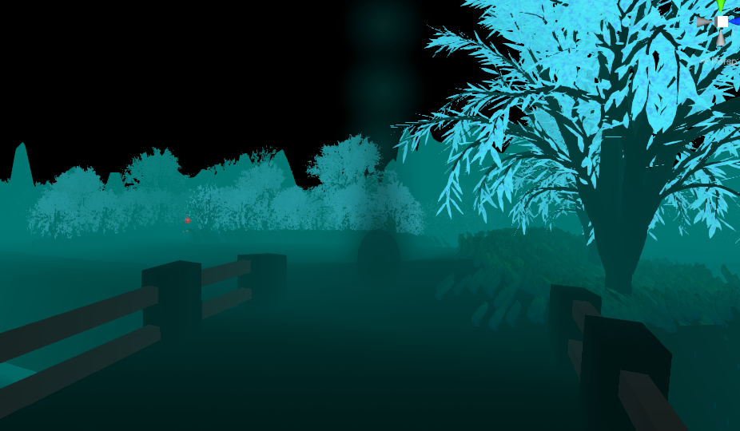

With most the things in place, I am going to play the game to test it out again, to see if it works.

[VR Horror Game Full Test Vid]

It all works like I want it to which I’m really happy with. The only that was wrong was the message at the start of the game telling the player where to go, but I can easily move it back more.

All I need to do is add my note and then I can hopefully package up the game for upload to itch. This is the note that I have designed that I am going to use. If I had more time, I would have made it better and more realistic but because of my time constraint this will be enough.
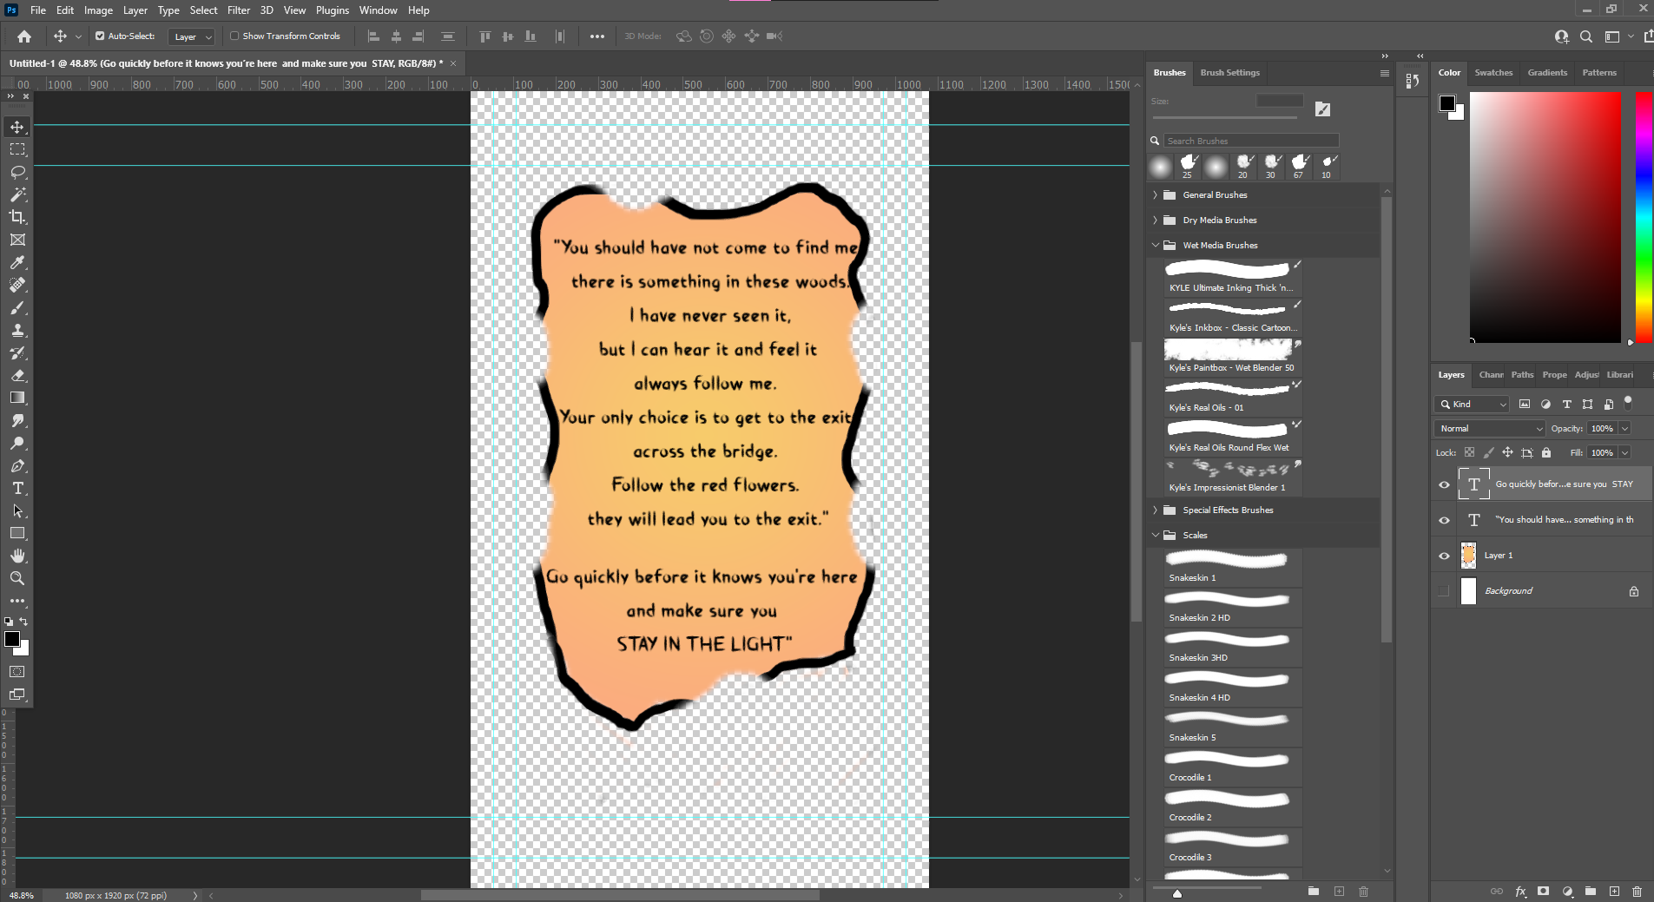

Here is what it looks like in game.
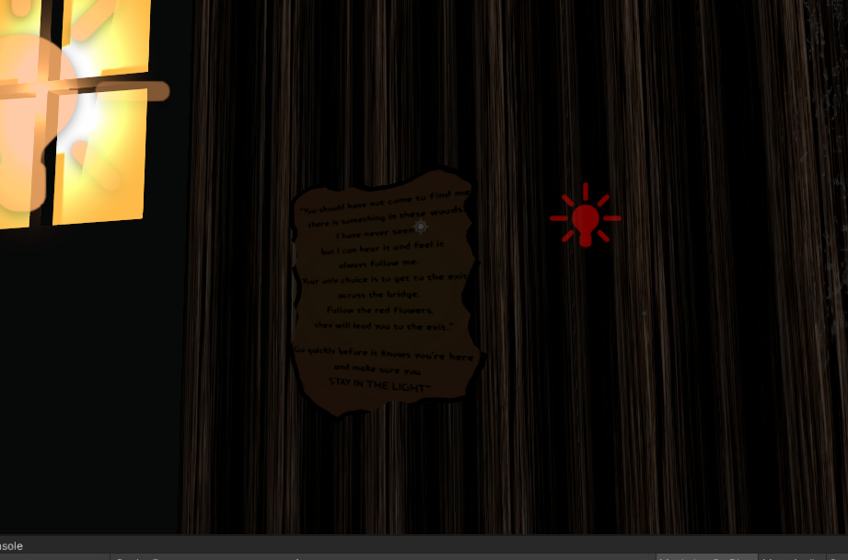

With everything done I can move on to Building the Unity file and uploading it to itch.

The building process was very simple and took around 30 minutes for it to finish. With that file I can now compress it and upload it to my itch.io page.
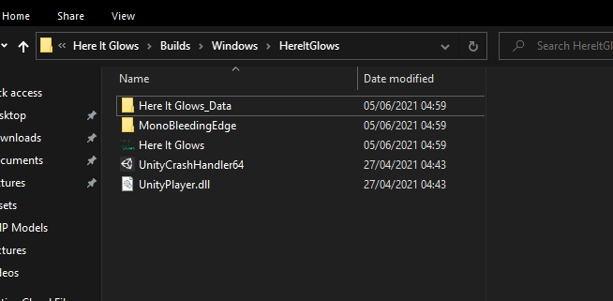

6th June 2021

Watching a random video about a game and why it ran so badly, I found out about Occlusion Culling and that it was easy to do in Unity. It never came to mind of using it because I didn’t know how to do it. Knowing this now helps my game run so much smoother because it does not have to render all the trees all the time. I built the game again and called it “HereItGlows v0.2”.

I wanted to make my itch.io page very simple so I matched the colour scheme with my game with using black and green.
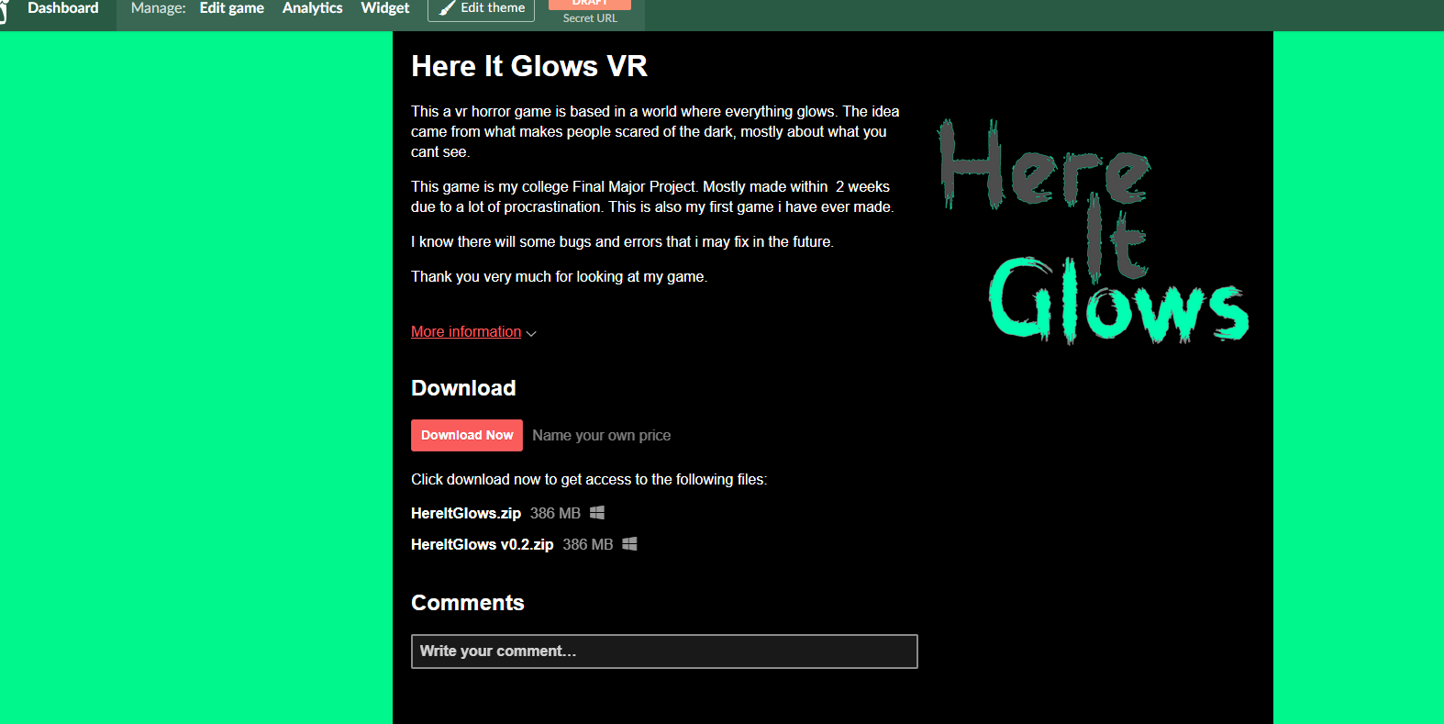

All I need left for my page is couple screenshot showing people what the game looks like. To take my screenshots I recorded a video of me playing the game, putting it in to Adobe Premiere Pro to export it all the frames as .png files. This may have not been the best way to do because it took 50 minutes to export all the files and there was 18 thousand+ pictures in the folder. So I have to find and pick five pictures to put on the game site.

With the pictures picked I have now published my game.

Itch.io site:
https://zuccu.itch.io/here-it-glows

Evaluation:
[Evaluation]

I intended to make a Virtual Reality Horror Game product with the theme of shadows, aimed at teenagers and adults because I wanted the player to be scared. I wanted it to have four scenes so I could have a beginning, middle, twist, and an ending. My intentions were to upload it to a game sharing website like itch.io, steam or epic games store. I wanted to make it in Unreal engine because I was more used to it at the time, and I thought the lighting is much better in Unreal.
I believe I achieved what I aimed for because my game is played in Virtual Reality. It is a horror game with some scary moments. My game has three scenes but the last scene I fused together my intended scene three and four. I had to switch my second scene because it was too ambitious in the time frame I had. I uploaded my finished product on to my itch.io account and can be downloaded by anyone that wants to play.
I ended up switching to the Unity Engine due to my VR not working with Unreal. This did set me back in my schedule because I had to re learn Unity.

I believe I stuck to my designs strongly and did not make any differences. All the models were either sketched out before hand or I had the idea in my head and built it. The map design I used for my game looks the same except for maybe one or two pathways covered in grass and trees. This was due to the game being too short because I had to shorten down the scenes. My planning skills have defiantly improved during my process of making this game. I have learnt to draw and write out all of my ideas I have on paper or a whiteboard, so I can always look at them if I need to remind myself. In my last unit project, I did not focus on my planning, and it showed in my final piece because there was no explanation to what I made. This time I have tried to explain as much as I can. The research that I did can explain what is in my game and what it is about.
At the start of making my game I did not think my idea was too over ambitious and thought I could easily do it all by myself but during my planning I did think to myself if I have gone to big with my idea. Making a fully playable VR game in the time span of eight weeks. Around halfway through making my environment I realised that it was way too big for what I needed but I could use it to my advantage by making the player small and the world big.
When I only had two weeks left to make the game, I was still filling in my environment, yet I still had to implement all my scenes and do a bunch of scripts. At this time, I did not think I would be able to finish my product by my deadline I was fortunately able do by making some small cutbacks.
Now when I look back at my original idea it was way to ambitious for a one-man team. If I had more time, then I think I would be able to make everything like I wanted. Also, if I spent more time on my game at the start, I would not have had to build everything just before my deadline. Even with my Gant chart it was to over ambitious to have my environment done in 3 days because it took a whole week to finish. I have learnt that I need to improve my time planning and know what I can a cant do myself.

As much as I struggled to get my VR game done due to not being motivated and stressed. In the last two weeks I feel I pulled myself together to get it done on time. I know I could have done some tasks better, but I thought they were good enough for the final product.
I think my environment came out better then I expected because my first idea was to use a bunch of objects for the grass but because it made the world lag a lot I had to find an alternative. I found the texture instance grass tool that Unity had. This looks much more effective because it looks more like natural grass and not models.
To this
These screen shots show the difference of using models and using the grass textures. I do really like it because the grass sways like I would imagine it to. It may be too tall but that works with its surroundings. When I was still aiming to make the game in Unreal Engine I did some experimenting of the grass and liked of how it looked. This was the main reason why I wanted to stay using Unreal but due to not being able to use my VR with it I had to switch.
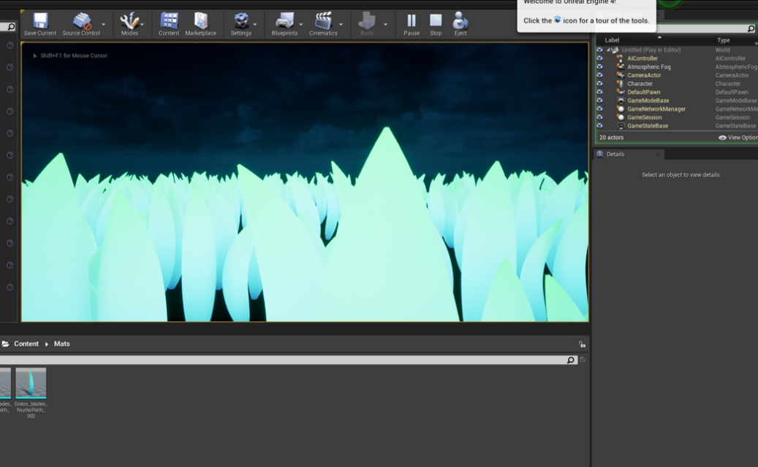

Another thing I believe I did is placing my trees in strategic places such as the outer walls to make it so the player cannot escape the map. I also placed them in the grass areas so the player cannot skip through some parts of the map. Making the trees different sizes also gave them much more variety, like natural trees.

I think my cottage and bridge could have been a lot more detailed. I rushed making them because I was running out of time for other more important tasks. If I had another chance to make them, I would have made the bridge much smoother and made the cottage more like a wooden hut with objects inside of it so players could look around. I would have also added more objects around the house to make It seem like someone was living there and they have randomly disappeared, that is what my first idea was, but it would have taken too much time modelling all the objects.

Throughout the process of me making my VR horror game I have learnt a lot about what and how much goes into making a game. Especially the importance of having enough time for certain tasks to be complete. One big thing I have learnt is the importance of having a team making a game because then you are not putting all the strain on yourself to get everything done. I thought I was good at modelling before this project, but I have realised I am not as good as I thought and have still got a lot to learn.
Before making this game, I had never made any sort of game product and had no idea how to do it, but I feel I have learnt enough that I am now confident to make games when I want to, because beforehand I was too scared of the amount of effort it would take.

If I had the chance to make my game idea again, there are a lot of things that I would change but only things that would make a difference. Spending more time on my game making stage and less time on the planning and designing stage would have helped me have more time, so I would not have had to rush getting everything done.

As much as I think about all that I could change to improve it, my game could have ended up being a lot worse than it is if I did not pull myself together.

For my own personal reasons, I should have tried to stay more focused because I was getting too distracted by other things going on, which ended in me procrastinating my game until I wanted to get it done. Trying to stay motivated in my work was also hard because I was doing so much at a time and constantly needed breaks between tasks. I feel motivation was my biggest reason as to my game could have failed.

Over the time of making this game the skills I already had have been improved. My modelling skills have increased because I can now make much more detailed models for what I need. I was able to use Unity before this project but only the basics. Watching tutorials, I have learnt how to make a full game with movement and triggers.

When I was first thinking of my ideas, I was really motivated to make a VR game no matter what because I love virtual reality and all the stuff you can do in it. I could have switched to just making a normal pc game but because I wanted to it to be VR, I at least wanted to achieve that even if the game was not finished.

I feel the overall success of my product went well because I still somehow have a finished product that is published for people to play. I believe it was my own performance that let me down. I did not stick to my plan of updating my journal every day and ended up doing it every three days. I feel like I could have made my game better by having more focus on it but having my first game be a VR game shows that I have skills that are not normal from a beginner.

In conclusion, as many problems as I have had I have still gotten past them with solutions. My VR game is not exactly as I imagined it to be. I thought it would be a lot more detailed and look much better. The look of the game now makes it seem more like a stylized art style, which I am happy with. I am happy with the way my finished has ended being like.

