FMP Story

Old Game Story

Scene 1:

Entrance

The player will wake up and be told that they need to go find someone in the forest, exploring the forest they come across a cottage. In the cottage they find a note that says the person went out into the forest to prove that there is something out there in the forest.

(The cottage is the only normal looking place in this world)

Scene 2:

Enemy Introduction

After the player reads the letter. The Shadow enters the cottage, and the player can’t move. The shadow circles the player whilst throwing objects the ground. When the shadow is face to face with player you can hear its breathing. The shadow leaves and the player can now move again. The player finds a torch and can pick it up and use it.

Scene 3:

Follow Scene

The player goes to the bridge crosses it and it collapses which means no return. Whilst exploring the forest the player will find the person’s body dead with a key and another note, the note says that the shadow is real and effects glow around it this is the only way you are able to see the shadow. Also, on the note it says to use the key to escape through the gate at the exit. Once you pick up the key you can hear the shadows breathing again but fading away.

Scene 4:

Escape scene

Since the player knows that the shadow is there, they know they now must escape and find the gate.

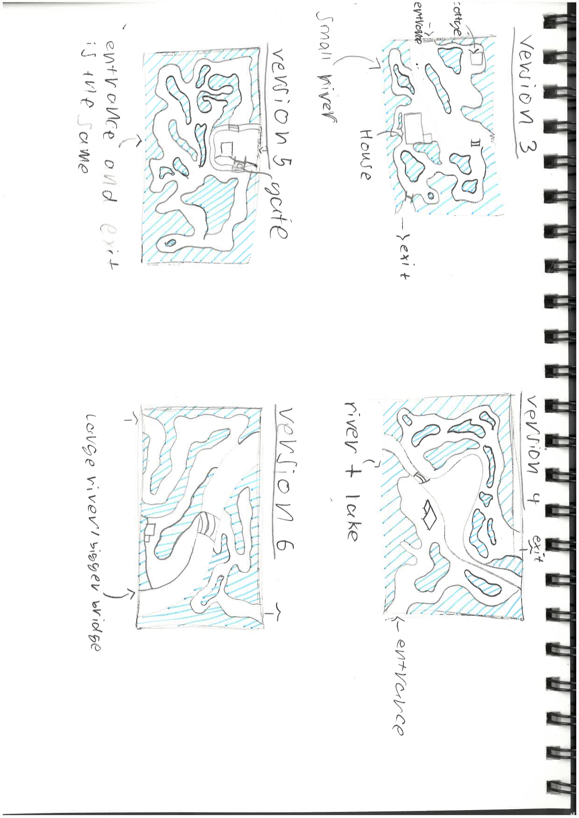Along the right pathway there will be fireflies and glowing flowers.

On the final version of the map, I will have to put a gate at the exit, so I remember to put it in the game.

Important parts:

Entrance

House

Bridge

Forest

Gate

Exit

Updated New Game Story:

Scene 1:

The player loads up the game and a text appears that says

“Dad told me to come to the woods to help him out with something but he hasn’t responded in a couple days so I came to look for him, he should be at his cottage just up the pathway.”

Scene 2:

Player gets to the college and sees a note attached to the door. The note says...

“You should have not come to find me, there is something in these woods. I have never seen it, but I can hear it and feel it always follow me. Your only choice is to get to the exit across the bridge. Follow the red flowers. they will lead you to the exit.”

“Go quickly before it knows you’re here and make sure you stay in the light”.

Scene 3/4:

The player starts to cross the bridge and just as they get halfway a shadowy figure disappears at the end of the bridge. (This should hopefully startle the player)

On each pathway to the exit there will be an event that happens with the shadow. Each one different

The player gets through the woods and finds the exit that is the tunnel. They walk through the tunnel and the screen changes to the ending screen.

This story will be easier to do in the game with the time that I have left. I really wanted to do my original scenes 2 but it would have taken way to long to make and I would have had to make changes to other objects and modelled more.

This story should make the game last maybe 5-15 minutes, which is good enough for me.